Hartest 2036

Neighbourhood Plan
Second Pre-Submission Consultation Draft

March 2018

Document created | 9 March 2018
Last saved | 9 March 2018

Table of Contents
Foreword 5
Section one: 7
Introduction to the Plan and to Hartest 7
1. Introduction 8
2. Hartest Past and Present 10
Section two: 12
Planning Policy Context 12
3. Planning Policy Context 13
Section three: 14
Planning Policies and Community Actions 14
4. The Plan 15
5. Vision and Objectives 17
6. Hartest’s Spatial Strategy 18
7. Housing 27
8. Natural Environment 39
9. Historic Environment and Design 51
10. Local Economy 56
11. Facilities and Services 58
12. Communications 62
13. Monitoring 65
Appendix 1 66
Appendix 2 67
Appendix 3 SWOT analysis 69
Glossary 71

Index of Policies
Policy HAR 1 – Hartest’s Settlement Pattern Policy 25
Policy HAR 2 – Housing Development within the Built-up Area Boundary 31
Policy HAR 3 – Housing Development outside the Built-up Area Boundary 32
Policy HAR 4 – The Paddocks, Lawshall Road 34
Policy HAR 5 – Housing Mix 35
Policy HAR 6 - Replacement dwellings 36
Policy HAR 7 – Affordable Housing on Rural Exception Sites 37
Policy HAR 8 – Biodiversity Assets 40
Policy HAR 9 – Protecting and maintaining features of biodiversity value 40
Policy HAR 9 - Hartest Area of Special Landscape Quality 43
Policy HAR 10 – Protection of important views 44
Policy HAR 11 - Settlement Gaps 49
Policy HAR 12 - Local Green Space 50
Policy HAR 13 – Protection of Heritage Assets 53
Policy HAR 14 – Design Principles 54
Policy HAR 15 – Economic Development 57
Policy HAR 16 - Provision and Retention of Services and Facilities 59
Policy HAR 17 – Crown Public House 60

Foreword

This is the revised draft Neighbourhood Plan for the parish of Hartest. It has been prepared by a Working Group of local residents established by the Parish Council and has been developed to establish a vision for the village and to help deliver the local community’s needs and aspirations for the period to 2036. Neighbourhood Plans were introduced in the 2011 Localism Act and, when complete, the Hartest Neighbourhood Plan will become part of the statutory town planning framework for the Babergh district.

The Working Group has consulted and listened to village residents and local organisations on a wide range of issues that are of concern to the well-being, sustainability and long-term future of our rural community. Every effort has been made to ensure that the policies and actions contained in this document reflect those of Hartest residents.

This document is the second “pre-submission draft Neighbourhood Plan”. This means that although the Plan has already been subject to a formal round of consultation, the amendments that we’ve made to it are of a magnitude that require us to undertake a further round of consultation. The main areas of change in this version are:
- Amendment to the way the clusters of homes around the village are defined;
- Amending the type and nature of new homes that can be built within the defined clusters
- Renaming of the Special Landscape Area to Area of Special Landscape Quality
- Refining the Replacement Dwellings policy; and
- The recognition that a site at The Paddocks on Lawshall Road has been granted planning permission for six dwellings since the last version of the Plan.

Following this round of consultation, the Plan will be submitted to Babergh District Council for them to take it through the final formal stages of the process. These will entail:
- a check that the Plan meets the legal requirements;
- a further 6 weeks consultation period for comments;
- an examination by a qualified, independent examiner; and
- if recommended by the examiner, progression to a local referendum

If the referendum shows local support (more than 50% of those voting being in favour) then the Neighbourhood Plan will proceed to adoption and be used by the local planning authority, as part of the statutory development plan, in the determination of planning applications in Hartest.

The Working Group has also engaged Places4People Planning Consultancy to help with the preparation of the Plan and Babergh District Council provided “critical friend” support via Rachel Hogger of Modicum Planning.

Photographs throughout this Neighbourhood Plan have been contributed by members of the Hartest Neighbourhood Plan Working Group or Places4People,. Where indicated, the photographs are protected by copyright and reproduction for any purpose other than as part of this document is not permitted.

Section one:
Introduction to the Plan and to Hartest

1. Introduction

1.1 The Localism Act 2011 provides the opportunity and tools for communities to shape how areas will change and grow through the preparation of their own Plans. These Neighbourhood Plans, if passed by an independent examination and supported in a local referendum, must be “made” by the local planning authority (Babergh District Council) and then will become part of the legal planning framework for the designated area.

1.2 In 2012, following consultation with all residents via an information sheet, a questionnaire and a public meeting, Hartest Parish Council decided to develop a Neighbourhood Plan. A Working Group of volunteers was formed to prepare the Plan and, in June 2014, in accordance with the Neighbourhood Planning Regulations, Babergh District Council formally designated the parish as a Neighbourhood Plan Area. Details of the application, publication and designation can be viewed on the District Council’s website under Neighbourhood Planning in Hartest.

Figure 1.1 The Designated Neighbourhood Plan Area
1.3 In the period since the formal designation, the Working Group has gathered information, undertaken consultation and considered which matters should be addressed by the Plan. This Neighbourhood Plan represents the conclusion of that work and provides a Plan that conforms with the strategic planning policies of the current Babergh Local Plan, the requirements of the National Planning Policy Framework and, most importantly, reflects the aspirations of the local community.

Purpose and scope of Plan
1.4 When work on the Neighbourhood Plan started, its purpose and scope were agreed and published. In summary, the Neighbourhood Plan was to be an approved, legally recognised, planning document that would describe how Hartest might develop as a sustainable, mixed, thriving community of residents and businesses over the next 30 years. Any recommendations for development would be driven by the expressed views and opinions of the community, informed by analysis of the historical and current physical characteristics and demographic composition of the village, with research into and discussion about likely future development needs.

1.5 The Plan would be confined to the Hartest Parish boundary. It was agreed that it would include a summary of opinions, needs and planning aspirations of all residents regarding a wide range of aspects of the village environment. It would identify:
- the predominant ‘Character’ of the various areas within the Parish, including a physical description of surrounding landscapes and the houses;
- the demographic development of the village over the past 30 years and consider likely changes in the future;
- the likely requirements for the range of accommodation needed for a sustainable mixed community of businesses and homes;
- those valued environmental, material and social assets that must be protected;
- possible locations which may provide suitable sites for development and the planning restrictions necessary to protect the character of the village.

1.6 The Plan would focus on the provision of homes but also consider the transport; education; health and wellbeing; leisure; employment; energy and communications requirements needed to support the community in the future.

1.7 This draft Plan has had regard to the original purpose and scope but, while being in line with the current adopted Babergh Local Plan Core Strategy, provides a framework for the period to 2036. However, the Neighbourhood Plan Regulations also require the draft Plan to:
- be appropriate, having regard to National Planning Policy;
- contribute to achieving sustainable development;
- be in general conformity with strategic policies in the development plan for the local area; and
- be compatible with EU obligations and Human Rights requirements.

How the Plan is structured
1.8 This Plan is divided into four distinct sections:
- Section 1: Introduction to the Plan and to Hartest

- Section 2: Planning Policy Context, both National and Local, to which the Neighbourhood Plan must conform
- Section 3: Planning Policies and Community Actions

- Section 4: Monitoring and Review: how the Plan will be monitored

How it has been prepared
1.9 The Neighbourhood Plan has been prepared in accordance with the requirements of the Government’s Neighbourhood Planning Regulations and, in particular, has involved considerable local community engagement to gather evidence and test options for the content of the Plan. In March 2018 , as illustrated in the key stages diagram below, the following has been completed.

2. Hartest Past and Present

2.1 The village of Hartest is situated in the area known as High Suffolk at the north-western extremity of Babergh district, on the B1066 and midway between Bury St Edmunds and Sudbury. Hartest Hill is said to be the steepest hill in Suffolk. The land is characterised by heavy loam and clay soils, originally covered by woodland and forest. Indeed, the name `Hartest` derives from the wooded nature of the landscape.

Fig 2.1

2.2 The main part of the village is set in the bottom of a distinctive valley, formed by a tributary of the River Glem, A section of the river runs through the central part of the village, in some cases forming part of the gardens of houses alongside it.
The village lies at the intersection of four roads which run roughly north-south and east-west and meet at a crossroads towards the southwest corner of the Green. The village is distinct in that, while there is one main built-up area focused around the vicinity of the Green, there are also a number of smaller groups of houses dispersed around the parish, primarily developed during the course of history around farms or former farms. Within the village and across the surrounding countryside, there are several farm buildings and barns associated with working farms.

Map identifying main village plus clusters

2.3 The core of the village, the Green, has an unusual triangular shape which relates directly to these historic features. This was originally larger and it appears the eastern edge was formerly on the other side of the river, and that the tightly packed houses along the present eastern edge are later encroachments. A timber-framed Wealden house, between `Hunters` and `Green Farm`, dates from c1470, which suggests that the encroachment is an early change to the village. At the south side of the Green, at the lower end, near the fording point of the river, stands the Church, (which was already there by 1086); the Hall or Manor House, now the Crown Inn, higher up the slope, and the Rectory to the south of the Church. On the western side the Green originally tapered into Somerton Road, as it still does on the North side, into Workhouse Hill. The surrounding landscape is an integral part of the village setting with access to extensive views across it from many of the houses and public spaces, from the footpaths and the four roads.

2.4 Today the central part of the village and a considerable area of land around it, the village setting, is designated as a Conservation Area and within it there are many listed buildings as well as, non- listed buildings and features of local importance.

Facilities and Services
2.5 The central built-up area of the village is also the focal point for the location of services and facilities. It is here that the village primary school, the GP branch surgery, the Crown public house, All Saints’ Church, the butcher, the garage and the Institute function rooms can be found. For a village of its size, there is a good range of services and facilities but there are ongoing concerns as to how secure they will remain in the long term. The village’s location primarily in a rural valley means that mobile phone signals are poor as is high-speed broadband coverage and this will become an increasingly important factor in determining decisions about living and working in the village.

Population
2.6 The 2011 Census resident population of the village was 426 which, remarkably, is about half what was recorded in 1851. When compared to Babergh district, the village had a significantly higher proportion of residents aged 60 to74 while those aged 25 to59 were proportionately lower than Babergh. In the period 2001 to 2011 (the UK Census dates) the structure of Hartest’s population has shown an increase in the proportion of children and those aged over 60 whereas there is a marked decrease in the proportion of residents aged between 16 and 44 (from 33% in 2001 down to 22% in 2011).

Fig 2.2 Age Structure Comparison

Parish Plan 2006
2.7 In Spring 2006 a Parish Plan was prepared by residents in the village with the support of Suffolk ACRE. The Plan contained 16 recommendations relating to:
- Leisure
- Community help and support
- Religion
- The school and the community
- Parish Council and Local Government
- Transport and communication
- The village environment
- Business or work based in Hartest
- Retail and allied facilities

2.8 This Neighbourhood Plan has a very different purpose to that of the Parish Plan but, during its preparation the Working Group has reflected on the recommendations of the Parish Plan to assess whether any may still be relevant today.

Section two:
Planning Policy Context

3. Planning Policy Context

3.1 The regulations governing the preparation of Neighbourhood Plans require that they conform with the National Planning Policy Framework (NPPF) and the strategic policies of the local development plan.

3.2 The NPPF requires that communities preparing Neighbourhood Plans should:
- develop plans that support the strategic development needs set out in Local Plans, including policies for housing and economic development;
- plan positively to support local development, shaping and directing development in their area that is outside the strategic elements of the Local Plan

3.3 At a more local level, the development plan comprises the Core Strategy and the “saved policies” of the 2006 Babergh Local Plan. Babergh District Council adopted a Core Strategy in February 2014. It provides the current strategic planning framework for Hartest which this Neighbourhood Plan has had regard to.

3.4 The Core Strategy identifies Hartest as a “hinterland village” within the “functional cluster” of Glemsford. What this means is that within the district there is a hierarchy of settlements ranked according to their size and the services they provide. The Core Strategy recognises that there are several larger villages (core villages) that provide a range of services and facilities for a cluster of villages around them. In so far as Hartest is concerned, the saved policies of the 2006 Local Plan and the policies in the Core Strategy are those by which planning applications will be judged.

3.5 In 2015 the District Council commenced the preparation of a new joint local plan in conjunction with Mid Suffolk. In August 2017 a consultation document was published that identified issues for the Plan to address and put forward options. The document proposed maintaining Hartest’s status as a hinterland village, maintained the existing Built-Up Area Boundary from the 2006 Plan and did not identify any potential sites for development that could be allocated in the Local Plan. At this time the joint local plan is at a very early stage of preparation and, therefore, is not a matter that has been given weight in the preparation of this Neighbourhood Plan. However, the District Council has stated in the consultation document that it will be seeking to minimise any conflicts between policies in neighbourhood plans and the emerging Local Plan.

Section three:
Planning Policies and Community Actions

4. The Plan

4.1 The content of the Neighbourhood Plan has been informed by information gathering and community consultation undertaken by the Working Group. This included a detailed questionnaire distributed to all households. A summary of the responses is available on the Hartest website. The results of these consultations have been taken into account in shaping the content of the Plan and its policies and potential community actions. The working group has also prepared an assessment of the village’s current strengths and weaknesses as well as the opportunities and threats (a SWOT analysis). These were tested through community engagement at the Drop-In event in September 2015 and were refined as a result of the feedback from the consultation. The SWOT analysis is included in Appendix 3.

Themes
4.2 The Plan focuses on six themes which emerged as a result of identifying issues and concerns during the surveys and information gathering stage of preparing the Plan.

Hartest Neighbourhood Plan Themes
- The Environment
- Homes
- Local Economy
- Facilities and Services
- Communications
- Village Life

4.3 These themes form the foundation for the content of the Plan and distinct chapters
cover policies and aspirations for each theme. Within each chapter there is a statement of objectives, a summary of what the evidence showed, with further discussion culminating in policy statements where appropriate and potential community actions.

Policies and Community Actions
4.4 The Neighbourhood Plan contains planning policies that will, when the Plan is completed, form part of the statutory development plan which will be used for determining planning applications in the parish. In addition to the planning policies, community actions are included in the Plan. It must be emphasised at the outset that community actions do not form part of the “statutory” Neighbourhood Plan but are included for completeness to identify other areas of improvement and change that residents have identified during the preparation of the Plan. The planning policies appear in boxes numbered HAR1, HAR2 etc and distinctly different boxes define the community actions where relevant.

Sustainable Development
4.5 There is no legal requirement for a Neighbourhood Plan to be accompanied by a sustainability appraisal. However, those preparing the plan must demonstrate how it contributes to achieving sustainable development. The National Planning Policy Framework defines three dimensions of sustainable development (economic, social and environmental) and there is a need for the planning system, including neighbourhood plans, to perform the following roles:
- an economic role – contributing to building a strong, responsive and competitive economy, by ensuring that sufficient land of the right type is available in the right places and at the right time to support growth and innovation; and by identifying and coordinating development requirements, including the provision of infrastructure;
- a social role – supporting strong, vibrant and healthy communities, by providing the supply of housing required to meet the needs of present and future generations; and by creating a high quality built environment, with accessible local services that reflect the community’s needs and support its health, social and cultural well-being; and
- an environmental role – contributing to protecting and enhancing our natural, built and historic environment; and, as part of this, helping to improve biodiversity, use natural resources prudently, minimise waste and pollution, and mitigate and adapt to climate change including moving to a low carbon economy.

4.6 In some limited circumstances, where a Neighbourhood Plan is likely to have significant environmental impacts, it may require a strategic environmental assessment. Draft Neighbourhood Plan proposals are therefore assessed to determine whether the plan is likely to have significant environmental impacts. Babergh District Council have undertaken this process as part of their duty to support the preparation of Neighbourhood Plans and have determined that a full Strategic Environmental Assessment of the Neighbourhood Plan will not be required.

5. Vision and Objectives

5.1 This section sets out the community’s vision for Hartest and the objectives developed to guide the policies that will deliver the Vision. The planning policies that follow are the delivery tools for realising the vision and objectives. In determining this vision, regard has been had to a desire, supported through community engagement, that the special qualities of the historic and natural environment of Hartest should shape how and where the village grows.

The Vision set out below has been agreed:

The parish of Hartest will:
- continue to be a thriving and inclusive community;
- retain the unique and special character of the built and natural environment;
- have sufficient homes, jobs, services, facilities and infrastructure to enable local people to live and meet their day-to-day needs in the local area.

5.2 To deliver this Vision, the following Objectives have been established for the Plan:
OBJECTIVE 1
Protect and enhance the landscape, biodiversity and natural habitats

OBJECTIVE 2
Protect and enhance the historic environment

OBJECTIVE 3
Manage the provision of housing to meet identified local needs

OBJECTIVE 4
Preserve existing and promote an increase in green spaces and provide better access to them

OBJECTIVE 5
Improve movement to, from and around the village

OBJECTIVE 6
Support and improve the provision of social, community, recreational and other leisure facilities

OBJECTIVE 7
Ensure that the level of services and infrastructure reasonably required to meet the day-to-day needs of the village are available

OBJECTIVE 8
Increase opportunities for local economic investment and growth

5.3 These Objectives were tested at the Issues and Options Workshop held at The Institute in March 2016 and have been adjusted to take account of the outcomes of that Workshop.

6. Hartest’s Spatial Strategy

6.1 As already noted, the current Babergh Core Strategy provides the strategic planning framework for Hartest, identifying it as a “hinterland village” within the “functional cluster” of Glemsford. What this means is that within the district there is a hierarchy of settlements ranked according to their size and the services they provide. The Core Strategy recognises that there are a number of larger villages (core villages) that provide a range of services and facilities for a cluster of villages around them.

Existing Policy Context
6.2 Policy CS2 of the Core Strategy states that hinterland villages will: “accommodate some development to meet the needs within them” and that “All proposals will be assessed against Policy CS11.” Built Up Area Boundaries (BUABs) provide a starting point for considering the relationship of new development with the existing pattern of development, providing the distinction between the built-up area and the countryside. Core Strategy Policy CS11 intentionally provides some flexibility for development beyond the BUAB subject to it meeting certain criteria, which are contained in Appendix 1 of this Plan. There are three key strands to it that are relevant to setting the planning policy context for the Neighbourhood Plan. In summary, it states that development proposals will be approved where:
- proposals score positively when assessed against Policy CS15 of the Core Strategy;
- a series of matters (which are set out in the table below) are addressed; and
- proposals are able to demonstrate a close functional relationship to the existing pattern of development for that settlement.
6.3 The following paragraphs consider the specific local characteristics relevant to these three principles.
i) Assessment against Policy CS15
Policy CS15 provides a comprehensive set of 19 criteria, reproduced in Appendix 2. The policy states that “All new development within the district will be required to demonstrate the principles of sustainable development and will be assessed against the presumption in favour of sustainable development…

The following statements relating to Hartest are relevant to the 19 criteria set out in Policy CS15:
- Hartest has important historic and architectural assets set within a distinctive high quality landscape.
- The parish’s species-rich hedgerows, ancient and community woodland contribute to high level of biodiversity.
- The river and its environs are classified as Flood Zone 3 by the Environment Agency. In terms of zoning, this means that flooding is most likely to occur in these areas. Appropriate consideration would be needed to locate any additional development in order to ensure no further flood risk to both existing and new properties.
ii) Matters in CS11
The matters which Policy CS11 specifies should be addressed are set out below, together with a summary of the Hartest specific responses. More detail on Hartest specific context is provided in the individual policy sections.

How Hartest relates to the specific Core Strategy CS11 criteria

Policy CS11 states that “Proposals will be approved where the following matters are addressed, where relevant and appropriate to the scale and location of the proposal”
CS11 Criteria | Neighbourhood Plan Response
i) the landscape, environment and heritage characteristics of the village | The main built up area of the village and a significant area of the surrounding landscape are a designated conservation area containing many listed buildings.  The village Character Assessment has identified  - important open spaces  - network of species-rich hedgerows, some probably ancient  - areas of environmental importance  Part of the parish is designated as Special Landscape Area (SLA) by Babergh Local Plan (2006) Saved Policies. The Neighbourhood Plan designates a new Area of Special Landscape Quality that replaces the SLA and reflects more accurately the distinct and special character of the local landscape.  The Suffolk Landscape Character Assessment shows that Hartest falls largely within the landscape character type of Undulating Ancient Farmland (a landscape of open undulating farmland with blocks of ancient woodland). The Assessment Management Guidelines for this landscape typology state “parishes in this landscape tend to consist of multiple clusters of varying sizes. The release of land for development should, if at all possible, reflect the local pattern. Ribbon development destroys this pattern and can have a considerable impact on the wider landscape”.
ii) the locational context of the village and the proposed development (particularly the AONBs, Conservation Areas and heritage assets) | The village has many protected areas and buildings:  - the ancient woodland of Ashen Wood and Bavins Wood, at the eastern edge of the parish, are Sites of Special Scientific Interest;  - there are two County Wildlife Sites;  - there are several tree preservation orders across the parish although all trees in the conservation area require consent to carry out works to them;  - there are 51 listed buildings, all of which are Grade 2 apart from All Saints Church which is Grade 1.
iii) site location and sequential approach to site selection | Hartest’s settlement pattern is distinguished by the clustering of houses around the Green. In the past, the settlement pattern was extended by ribbon development primarily to the south along The Row. This all falls within the current Built Up Area Boundary (BUAB) in the local plan. There are opportunities for acceptable development within and or immediately adjacent to the BUAB, albeit limited by environmental and other planning policy considerations. In addition, as is described in the Character Assessment, there are several distinct groups of houses and farms spread around the parish separated by open countryside.  There are some opportunities for acceptable infill within these smaller clusters whereas, because of the environmental sensitivities there are limited opportunities for acceptable development immediately adjacent to the BUAB . In addition, further extending ribbon development could be damaging to the existing character and wider landscape and could result in the unacceptable coalition of the distinct groups of houses.  Any new development should respect the existing settlement pattern of the village and this may mean, in some instances, locations away from the BUAB are considered.
iv) locally identified need - housing and employment, and specific local needs such as affordable housing | - The village has several young people who will need to move out of their current accommodation at some point within the next 10 years  - There is evidence that people want to move within the village but that the lack of suitable housing has not made this possible;  - There is a shortage of smaller homes in the village when compared to the local average, with more than half the homes having four or more bedrooms;  - The housing needs survey identified that 21 households have at least one person with healthcare challenges ­ most homes have no adaptations which might benefit those with health problems;  - There are 5 households on the Babergh Housing Register claiming a local connection to Hartest and wanting accommodation in the village. Of the 5, two are registered for 1-bed affordable accommodation and three are registered for 2-bed affordable accommodation.  Thus there is an urgent need for small low cost or ‘affordable’ housing, especially for young people / first - time buyers and some need for easy-access one storey dwellings.  There is also a need for more employment opportunities in the village, currently limited by lack of small businesses & enterprises, which are, in turn, hampered by poor communications and absence of suitable premises.
v) locally identified community needs | - There remains a need for a shop serving the day-to-day needs of the village;  - Securing the long-term provision of play equipment is important for children to meet and play;  - The school roll is anticipated to decline over the next few years and more family housing will help to secure its long-term future;  - Measures to reduce the impact of through traffic in the village are needed, especially in the historic core around the Green;  - Provision of better internet / mobile telephone communications for all residents and businesses to encourage home-working and appropriately-sized and sited new businesses and enterprises.  - Provision of improved public transport to Bury St Edmunds and Sudbury, especially for young people, the elderly, and those without private transport.
vi) cumulative impact of development in the area in respect of social, physical and environmental impacts | There is limited capacity in the foul sewerage network, pumping station and the treatment plant at Glemsford.  The many country lanes in and around the village are susceptible to damage and a change of character resulting from an increase in traffic generated from development in the vicinity of Hartest, including any further growth at Glemsford
In addition to the above, development in hinterland villages must also:
i) be well designed and appropriate in size / scale, layout and character to its setting and to the village | Hartest has a large number of listed buildings and buildings of architectural significance as well as an extensive conservation area.  The views into and out of the village are of considerable importance in establishing the character and form of the village.  There is a variety of design styles reflecting the use of traditional local materials but also groups of houses that have employed designs and materials typical of the recent trend for standardised approaches to mass house-building.
ii) is adjacent or well related to the existing pattern of development for that settlement | The settlement pattern of a tightly knit main village centre with separate groups of houses set within an identified special landscape places restraints on site location. See analysis under iii) above.  There are limited sites immediately adjacent to the BUAB that would be appropriate for new development. This is partly because of the potential damage that ribbon development can have on the wider landscape also because they have poor access.  There are also visually important gaps between the BUAB and the separate groups of houses that could be weakened by unsympathetic development and which have been have been identified to keep the individual clusters distinct.
iii) meets a proven local need, such as affordable housing or targeted market housing identified in an adopted community local plan / neighbourhood plan | Hartest’s identified local needs are laid out in iv) above and are based on the results of the 2015 Housing Needs Survey and the information from the Babergh Housing Register. Currently a:  - need for smaller, family homes to redress the balance of larger homes and help accommodate children;  - need for smaller, family homes for locals to downsize and a few larger homes for locals to up-size;  - need for homes to be more accessible for those with mobility limitations.
iv) supports local services and/or creates or expands employment opportunities; and | Paragraph v) above (locally identified community needs) outlines the concerns relating to the provision and retention of local jobs and services. These concerns have been identified through the community engagement in preparing the Neighbourhood Plan.
v) does not compromise the delivery of permitted or identified schemes in adopted community/village local plans within the same functional cluster | There is no other current village plan for Hartest. The need to take account of the recommendations of the 2006 Parish Plan have been tested through consultation and have, where appropriate, been included in this Neighbourhood Plan.

iii) Close functional relationship to the existing pattern of development
With regard to the third strand of CS11, the supporting text to Policy CS11 clarifies that the Built-Up Area Boundary (BUAB) defined in the 2006 Local Plan Saved Policies provides a useful starting point when considering the relationship of proposed development to the existing pattern of development in a settlement. The policy however allows for a degree of flexibility for settlements such as Hartest where clusters of development exist outside the BUAB and where areas of land immediately adjacent to the BUAB may not be appropriate for development.

6.4 The rationale behind the Settlement Pattern Policy (Policy HAR1) is to provide an overarching approach to all types of development proposals that may come forward during the Plan period. The intention is that it provides clarity to the application of Core Strategy Policies CS2 and CS11, although it is important to emphasise that Hartest’s Core Strategy designation as a Hinterland Village recognises that new development in such settlements “will depend on their individual capacity to accommodate growth.”

Policy Rationale
6.6 It is considered the existing settlement pattern contributes significantly to the character of the village and that it should therefore be retained. On the basis of the criteria in Policy CS11 the initial starting point for the consideration of potential locations for future development will continue to be within the BUAB as illustrated on the map below. This reflects the historic focus for where the main development in the village has taken place over many years and, rightly, a priority for new development consideration throughout the lifetime of the Plan. The Neighbourhood Plan will continue to support development within the BUAB that is of an appropriate scale that has regard to the role of the village in the Glemsford Functional Cluster, the setting of the site and the character of its surroundings.

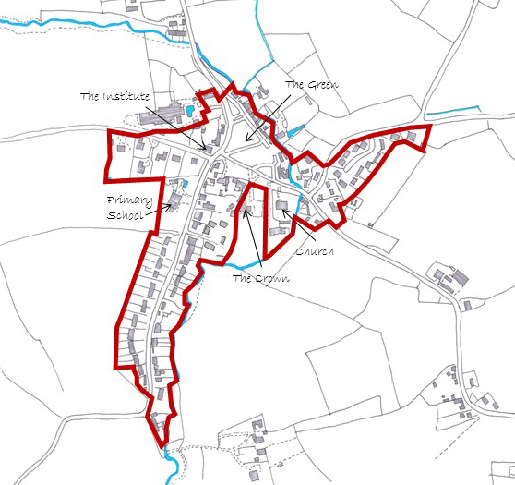

BUAB Map
Fig 6.1

6.7 However, recognising that opportunities for new development within the BUAB are limited and, in accordance with the strategic approach in the Core Strategy, new development outside but immediately adjacent to the BUAB will be supported where there are no unacceptable impacts on environmental constraints such as heritage assets, identified visually important gaps or where there will be no adverse impact on the wider landscape resulting from, for example, ribbon development.

6.8 Beyond the BUAB and reflecting the historic settlement pattern the Plan restricts new ribbon development from creeping along the roads that would result in the gaps between the distinct clusters in the village being eroded.

6.9 As identified above, Hartest is distinct in the way that it has grown and evolved around clusters of homes. These clusters remain distinct and separate today and, combined, are home to a large proportion of Hartest residents. The largest of these are;
- Cross Green;
- Foster’s;
- Pear Tree Farm; and
- Old Mill
and their location in relation to the BUAB is illustrated on the map below.

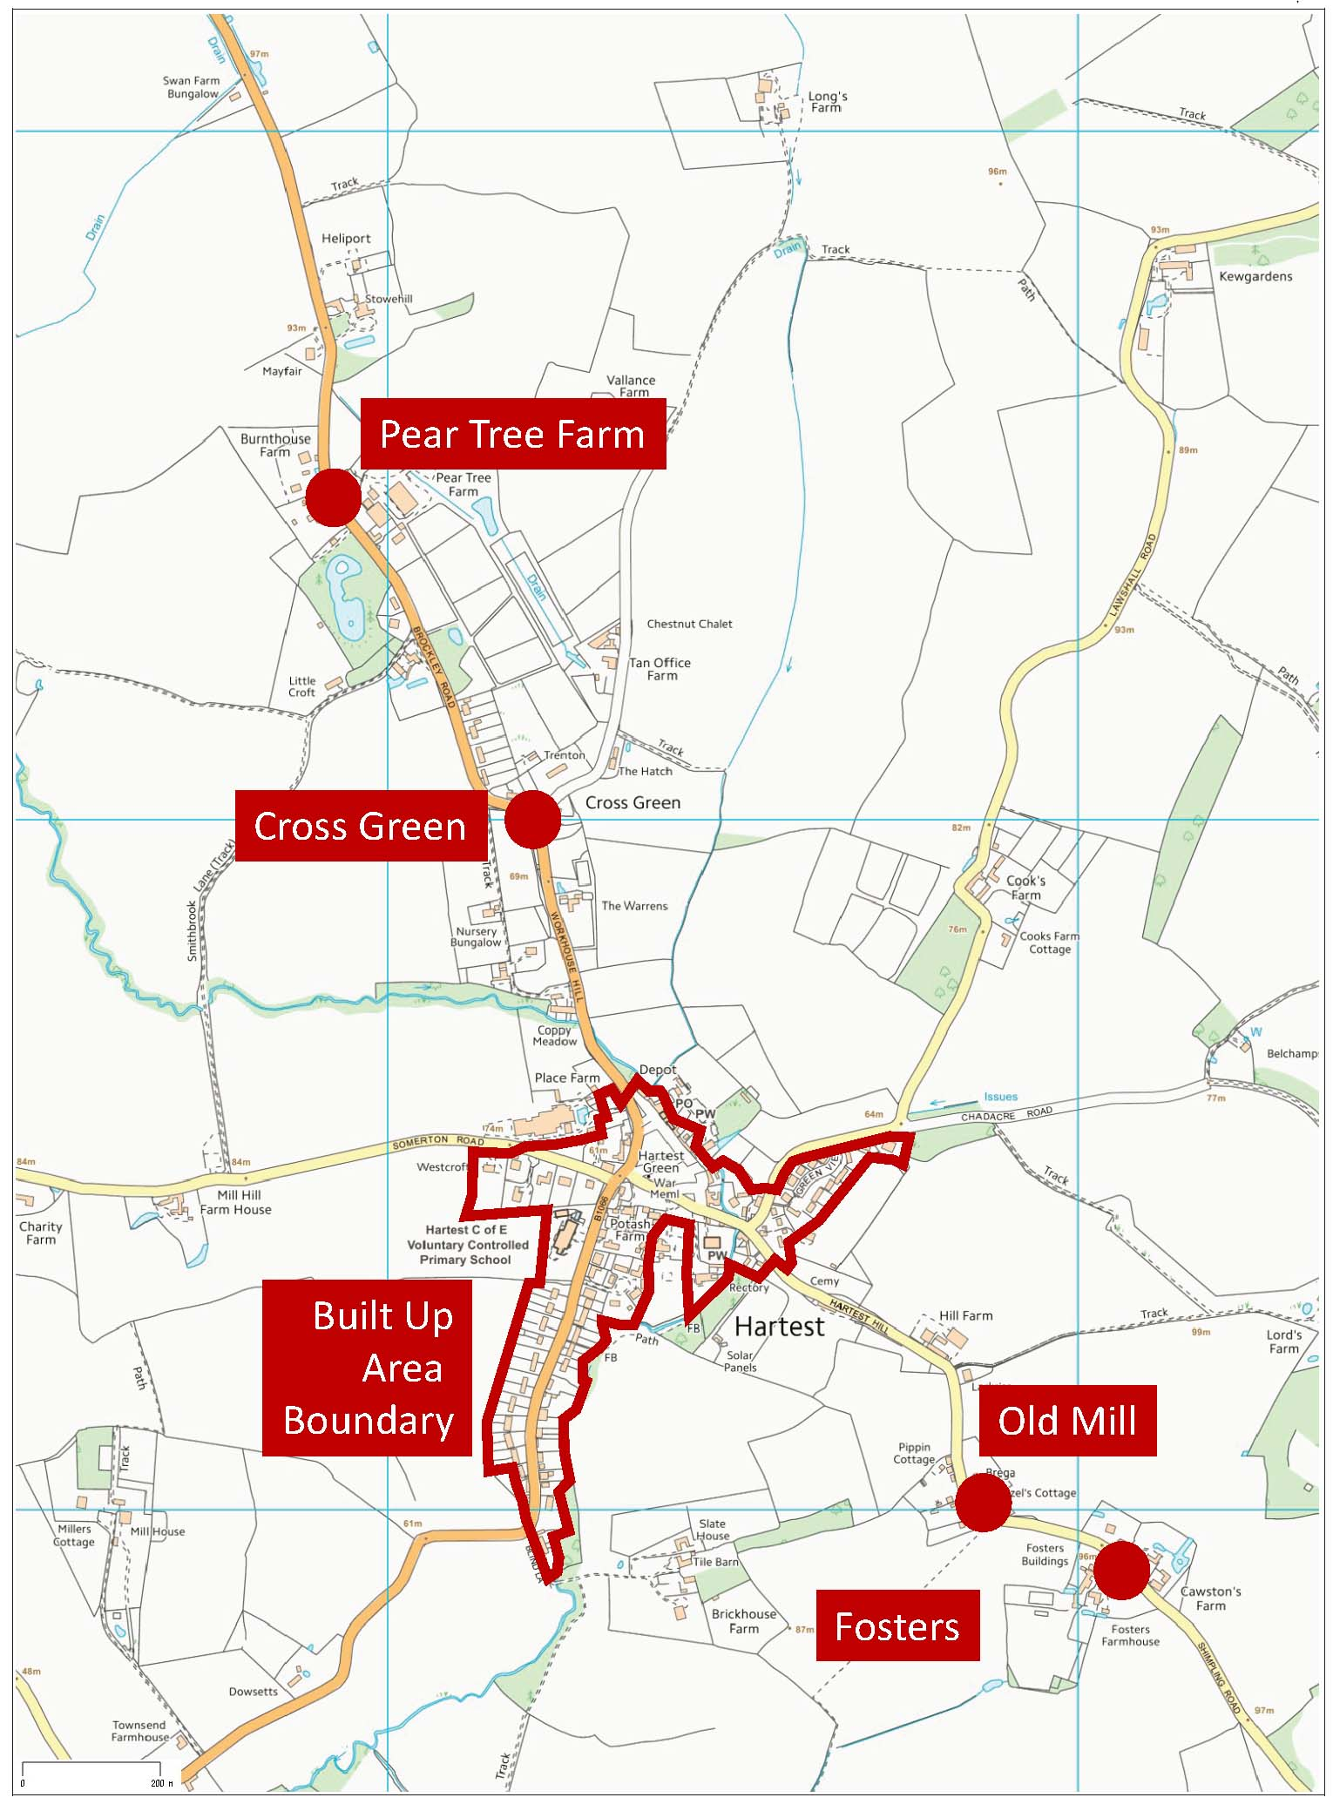
Figure 6.2 Location of Clusters in relation to BUAB

Cross Green
This is by far the largest cluster outside of the village core with around 20 dwellings. There are no farms within this cluster so the older houses are modest in scale.

This cluster is around 400m from the Village Green and is well connected via a narrow footpath which is regularly used by people walking into the village.

Pear Tree Farm
This cluster is the northern most of the four identified clusters, and straddles the B1066. It is made up of some larger dwellings and farm buildings, and some smaller dwellings, all in relatively close proximity to each other. The buildings are generally set back from the road edge with hedges protecting them from the highway.

Old Mill and Foster’s
Old Mill cluster is on the high ground above the steep hill out of the village, known as Shimpling Road. Within it are several listed buildings, one of Hartest’s three mills, a pair of mill workers cottages and two late 20th century farm workers cottages.

Foster’s
This cluster lies around 600 metres from the Village Green. It has a distinctive character which is defined by the fact that all the buildings are either medieval timber framed houses or former barns converted into houses located within a very densely planted setting.

6.10 Within the four distinct and closely-knit clusters identified in this Plan, there may be limited opportunities for supporting proposals for a single dwelling or one pair of semi-detached dwellings on an undeveloped plot. Such a site should;
- have a direct frontage onto the highway and
- involve the development of a small gap in an otherwise built up frontage.

It is essential that all development proposals are small in scale if they are to be appropriate to the setting and scale of their immediate surroundings. See section 7 for provisions specific to residential development.

6.11 New development on sites that do not meet the criteria set out in HAR 1 and HAR 3 would be classified as development in the countryside and proposals would need to accord with policies that cover such circumstances.

Policy HAR 1 – Hartest’s Settlement Pattern Policy
Development proposals within the Hartest Built-Up Area Boundary, as defined on the Policies Map, will be permitted provided they accord with the other provisions of the adopted Development Plan.
In addition, outside the Built-Up Area Boundary, small scale development proposals will be permitted, provided they accord with the other provisions of the Development Plan and where they:
- are small scale in nature;
- contribute towards meeting local needs; and
- are well related to the existing pattern of development within Hartest
To be considered “well related”, sites should be immediately adjacent to the Built-Up Area Boundary (subject to the built and natural environmental constraints set out in this Plan) or on small infill sites that are located within the curtilage of an existing dwelling within the confines of the following clusters:
- Cross Green;
- Foster’s;
- Pear Tree Farm; and
- Old Mill
Sites that do not meet the above criteria will be treated as countryside and development proposals in these areas will need to have regard to other relevant national and local planning policies.

7. Housing

7.1 Objective
Manage the provision of housing, including affordable housing, to meet identified local needs

What the evidence shows
7.2 Information has been gathered to guide and shape the Neighbourhood Plan policies for housing. In summary, the key points are:
- Household surveys and the Babergh Housing Register have not identified a significant unmet housing need in the village
- Fifty percent of the existing homes have 4 or more bedrooms, a much higher proportion than surrounding villages
- Two thirds of residents live in 1 or 2 person households
- One third of the population are aged over 60
- 11 new homes were built in the village between 2007 and 2015, an average of 1.4 homes a year.

7.3 Traditionally the village has grown by single plots or small groupsand has evolved this way over hundreds of years, typically around the farmsteads that are (or were) a common feature of this ancient agricultural landscape. Consequently, there are a number of smaller groups of houses around the parish, although the nucleus of the village remains focused around The Green where the majority of the recent housing development is located. The most recent group of houses to be built is on a brownfield site at Banham’s Yard, (the old coach depot) off The Row. Prior to this, the largest single development of housing in recent years has been the development of 11 detached houses at Greenview. When consulted on the amount of housing growth that should take place in the village over the period to 2031, the original time frame envisaged for the Plan, most residents felt that it should remain at about the same rate of growth experienced since 2007.

Fig 7.1 Location of some recent developments

Population
7.4 The most recent population figures for Hartest indicate that the parish has a
population of 446 (Office for National Statistics – 2014), an increase of just 19 people over the 2001 Census population. However, detailed examination of the structure of the population indicates that there is a high proportion of residents of retirement age when compared with the Babergh district. One third of the population is aged over 60 and there is a relatively small proportion that are aged 16 to 44 despite the presence of a primary school in the village.

Fig 7.2

Housing
7.5 In 2011 there were 210 houses in the village, although 11% did not have residents that usually live there. Some 52% of the homes were Council Tax Band E or above, compared with the 20% for Babergh as a whole. Dwelling occupancy rates, the number of people living in each house, are similar to those for Babergh as a whole, with two-thirds of homes being occupied by up to two people. Between 2001 and 2017 twenty new homes had been developed in the village.

Fig 7.3

Identifying Local Housing Growth
7.6 The 53 Core and Hinterland Villages identified in the Babergh Core Strategy, which include Hartest, are planned to accommodate at least 1,050 new homes in the period 2011 to 2031. In the five years 2011 to 2016 a total of 537 new homes had been completed in the Core and Hinterland villages, which amounted to just over 50% of the minimum planned provision being delivered in the first five years of the Plan. This suggests that there is no pressure to identify sites in Hartest in order to meet the Hinterland villages’ housing requirements but that, as the Core Strategy suggests, the environmental and infrastructure capacity should guide how much housing should be provided for. The Core Strategy specifically states that the minimum requirement for Core and Hinterland Villages is not “a sum simply to be divided equally or randomly” between the identified settlements. As such, the Neighbourhood Plan has not sought to take such an approach to identifying how many homes will be built. As the Core Strategy notes, there will be many factors that influence the level of development and Hartest can make a positive contribution to meeting the minimum housing numbers having regard to the village’s function and the need to preserve the distinct local environmental characteristics.

7.7 This Neighbourhood Plan provides a planning framework for the period to 2036. This end date has been chosen to coincide with the emerging joint Babergh / Mid Suffolk Local Plan. It is not known at the time of preparing this Neighbourhood Plan what the likely housing growth levels will be or what the strategy for the location of that growth might be. The consultation document identified that, based on the most recent Strategic Housing Market Assessment, an additional 4,210 sites for new homes needed to be identified across the Babergh district between 2017 and 2036. The document also sought views on the distribution of that housing, with the 25 Hinterland Villages taking between 5% and 15% of the housing depending upon which strategy was chosen for distributing the growth. This would total to between 210 and 421 homes across all villages in this category of settlement.

7.8 Based on the above information, it is considered that the housing growth for Core and Hinterland Villages in the current Core Strategy and approach to the distribution of this growth remains an appropriate basis to plan for the amount of housing to be provided in Hartest. As such, the Core Strategy and the Joint Local Plan consultation document do not identify the minimum number of homes that Hartest should contribute to the overall need. What is evident, however, is that the number is likely to be a small proportion of the overall requirement and that there is no expectation from the Core Strategy to allocate sites for development in Hartest.
Housing Needs Survey
7.9 Every household in the village was invited to participate in a housing needs survey in September 2015. A total of 97 responses were received, representing a response rate of just under 50% of the households in the village. The results of the survey can be summarised as follows:
- There is a small number of responses from those wishing to move within Hartest who are unable to do so. This indicates a housing demand which appears primarily to be for 4 bedroom homes and a lower demand for 3 and 2 bedroom homes;
- The village has a number of young people who will need to move out of their current accommodation at some point within the next 10 years. If they are to remain in the village then their needs will need to be considered;
- Around 20% of responding households have at least one person with a long term health concern or disability, many of these have multiple health challenges. It may be useful to consider whether current homes can be adapted to suit the ongoing needs of these groups, or whether additional more specialist housing within the village can be justified;
- Whilst most people in the village have no difficulties meeting their ongoing housing costs there are a small number of households where these are a real concern; and
- Almost half of responses come from households with at least one person aged over 65. The majority of these have lived in the village a long time and many can foresee a need or desire to move in the future. The needs of this group should be considered in future housing developments.

At the time of preparing the Neighbourhood Plan there were five households on the Babergh Housing Register claiming a local connection to Hartest and wanting accommodation in the village. Of the five, two needed one bed affordable accommodation and 3 required two bed affordable accommodation. This size of home is currently unrepresented in the village, with 17% of homes being of one or two bedrooms compared with the Babergh district figure of just over 32%.

7.10 Based upon this information, and the historic and environmental constraints, the Neighbourhood Plan does not specify a minimum number of new homes that will be built in the village over the next 20 years. Instead, it provides enabling policies by which proposals for new homes in the village will be considered.

Built-Up Area Boundary
7.11 The Babergh Local Plan (2006) designated a Built-Up Area Boundary (BUAB) for the village that encompassed the main part of the village around The Green and extending south along The Row, as identified in Fig. 7.5 below. The Local Plan allowed for “infill” development of new homes on plots within the BUAB and this policy approach was continued in the 2014 Core Strategy. The Hartest Neighbourhood Plan confirms the Built-Up Area Boundary as that defined in the 2006 Babergh Local Plan.

7.12 Hartest’s designation as a Hinterland village in the Babergh Core Strategy means that it is only expected to accommodate growth that meets local needs. With that in mind and given the relatively low projected need over the plan period, the process of preparing the Neighbourhood Plan did not involve identifying any sites to allocate for future housing development. . Instead, the Plan provides policies against which, and combined with the NPPF and Babergh development plan, proposals for new development can be assessed.

7.13 During the preparation of the Neighbourhood Plan, residents expressed a strong desire to place protecting the quality of the natural and historic environment as a higher priority than accommodating growth.

7.14 At the Issues and Options Consultation event in March 2016, attendees were asked to consider whether they wanted to focus on the delivery of new homes in the village or whether the historic and natural environment should inform and guide the capacity for and location of new development. The results of that consideration, as illustrated in Fig 7.4 (adjacent) indicate an overwhelming preference for an environmental led approach to the Plan. Therefore, and having regard to the NPPF and the current strategic policies of the local development plan, the strategy for accommodating future development in Hartest will be based on meeting locally identified needs in a manner that respects the high quality and locally distinct historic and natural environment of the village. Through the preparation stage of this Neighbourhood Plan, assessments have been made of the landscape and built character of the village to guide development to those parts of the village where there will be the least harm on the environment and upon local infrastructure.

7.15 In determining where new housing could be located and in accordance with the strategic policy framework of Policy CS11 of the Babergh Core Strategy, a sequential approach has been undertaken to identify where capacity might exist which would not have a potential detrimental impact on the historic built environment, the character of the village and on natural habitats and landscape setting. During the lifetime of this Neighbourhood Plan some opportunities may arise for sympathetically designed single infill plots or small groups within the designated Built-up Area Boundary (BUAB). There will be a general presumption in favour of such development as long as it satisfies other policies in the Neighbourhood Plan, the Core Strategy and the NPPF.

Babergh’s current planning policies allow for development within the Built-up Area Boundary and Policy HAR 2 reflects this.

Policy HAR 2 – Housing Development within the Built-up Area Boundary
Within the Built-Up Area Boundary, as defined on the Proposals Map, there is a general presumption in favour of residential development in the form of single dwellings and small groups.

The scale and nature of all schemes must ensure an appropriate level of services, facilities and infrastructure, including primary school capacity, are available or can be provided to serve the proposed development.

Fig 7.5 The Built-Up Area Boundary for Hartest

Adjoining the Built-up Area Boundary
7.16 The BUAB is wholly within the conservation area and, at the time this Plan was prepared, there appear to be limited prospects for acceptable development coming forward in the foreseeable future, other than possible conversions or small scale infill that would have regard to the historic and natural environment setting of the site. The Babergh Core Strategy recognises such limitations across the district and Policy CS11 allows for new housing to be built outside the BUAB subject to certain criteria being satisfied. Due to the strategic nature of the Core Strategy policy, these criteria cannot be overridden by the Neighbourhood Plan. Because of the environmental and historic setting of the BUAB, and the desire not to permit further ribbon development, there are considered to be few opportunities for accommodating new development immediately adjacent to the BUAB without having a significant detrimental impact on the character and setting of the conservation area. Given the sensitivity of these potential development locations, it will be essential that planning applications for new housing outside the BUAB are accompanied by a Visual Impact Assessment. This is an assessment of the existing character and appearance of the immediate locality, and will need to demonstrate how the proposed scheme may be incorporated into the landscape without resulting in significant harm being caused to either visual, historic and/or neighbouring residential amenities.

Clusters
7.17 The sequential approach to considering suitable locations for new homes has then led to the consideration of opportunities for new homes within existing clusters of homes around the parish as identified in Policy HAR 1, namely at Cross Green, Pear Tree Farm, Fosters and Old Mill. It is considered that there are some opportunities within the confines of these clusters to construct a single dwelling or a pair of semi-detached dwellings that are small in scale on an undeveloped plot fronting onto the highway provided that other design and impact considerations are taken into account.

7.18 In 2015 the government published “Technical housing standards – nationally described space standard” (DCLG 2015) setting out minimum gross internal floorspace standards for a range of house sizes. Whilst it is recommended that dwellings meet these minimum standards, it is considered that, given the environment, location and setting of the clusters, there should also be a restriction on the maximum size of dwellings. Having considered the requirement for smaller dwellings to create a more balanced housing stock in the village, the Neighbourhood Plan limits new dwellings proposed within the identified clusters to a maximum gross internal floor area of 98 square metres excluding garage space. This is some 20% larger than the minimum space standard for a three-bedroomed six-person house and takes its reference from the RIBA research document “The Case for Space: the size of England’s new homes” published in September 2011.

7.19 Proposals for development outside a defined cluster or which would result in the extension of the cluster, will be treated as being in the countryside and determined in accordance with other policies in the Local Plan and NPPF.

An outcome of the analysis for potential housing development outside the BUAB is stated in policy HAR 3

Policy HAR 3 – Housing Development outside the Built-up Area Boundary

Proposals for new housing development outside the Built-Up Area Boundary will be permitted where they take the form of:
- single dwellings and small scale groups of up to 4 dwellings outside, but immediately adjacent to, the Built-up Area Boundary; or
- one dwelling or a pair of semi-detached dwellings, each having a maximum gross internal floor area of 98 square metres excluding garage space, on an undeveloped plot that is:
i) located within the curtilage of an existing dwelling;
ii) adjacent to or fronting an existing highway; and
iii) within a closely knit ‘cluster’ as defined in Policy HAR1.

All proposals should be accompanied by:
- a completed Core Strategy Policy CS11 assessment checklist, which takes into account any cumulative impact taken with other existing commitments in the village;
- a Landscape Visual Impact Assessment; and
- where the site is located in the conservation area or adjoins a listed building, a statement, proportionate to the assets’ importance, describing the significance of the heritage asset affected, including any contribution made by their setting.

The scale and nature of all schemes must ensure an appropriate level of services, facilities and infrastructure, including primary school capacity, are available or can be provided to serve the proposed development.

Permission will not be granted where:
- a proposal harms or undermines a visually important gap or important hedgerow that contributes to the character and distinctiveness of the rural scene; or
- development would have an adverse impact on the environment or highway safety; or
- a proposal comprises ribbon development that would result in the coalescence of settlements and identified clusters, or
- a proposal would harm the Hartest rural economy by prejudicing the continuing operation of an otherwise viable farming enterprise.

Note: A small undeveloped plot is one which could be filled by one detached or a pair of semi-detached houses where the plot sizes and spacing between dwellings is similar to adjacent properties and thereby respects the rural character and street scene of the locality

Land at The Paddocks, Lawshall Road

7.20 During 2017 a planning application for six single storey dwellings at The Paddocks, Lawshall Road was submitted to Babergh District Council. The site is located outside the BUAB and, in 2016, had previously been the subject of a planning application for six dwellings that resulted in a number of objections, including from the Parish Council, and was consequently refused for the following reasons:
- “Harm to the open nature and transition character between the urban area of the village and the open countryside to the detriment of the Conservation Area and Special Landscape Area.
- Unsuitability of Lawshall Lane for intensification of use and harm to pedestrian safety given narrowness, sharp bend and lack of footway.
- Unsustainable development the benefits of which outweighed by harm to:
  - Relationship to pattern of development in the settlement
  - Lack of respect to the landscape, street scape/townscape/heritage assets, important spaces and historic views
  - No positive contribution to local character of area
  - Development of an important visual feature in its undeveloped form
  - Detriment to highway safety”

7.21 The site is located in an area that the March 2017 Draft Neighbourhood Plan identified as an Important Gap, forming part of an important view, and is 35 metres from the BUAB. The number of dwellings proposed was also contrary to the Draft Plan that only supported groups of up to three homes adjoining but outside the BUAB. The 2017 application attracted equal opposition and the Babergh Planning Committee was recommended to refuse it. However, at their meeting on 7 February 2018 the Committee approved the application and, despite the proposal being contrary to the policies of this Neighbourhood Plan, it is accepted that this decision cannot be reversed and that these homes are likely to be built during the Neighbourhood Plan period.

7.22 Because the approval at The Paddocks was made after the base date of this Neighbourhood Plan (April 2016) it counts as part of the contribution towards meeting the housing needs of Hinterland Villages referred to above. The site is therefore identified in the Neighbourhood Plan for development in accordance with the planning permission. This does not set a precedent for the approval of similar developments in the future as the policies of the Neighbourhood Plan, once adopted, will be a material consideration in the determination of planning applications. The “allocation” of the site in the Plan also means that, for as long as Babergh does not have a 5-years supply of housing land, (but does have a 3-years supply) then the policies in the Neighbourhood Plan can be used in the determination of planning applications for new housing in the village.

Policy HAR 4 – The Paddocks, Lawshall Road

A site of 0.38 hectares at The Paddocks, Lawshall Road, as illustrated on the Proposals Map, is identified for a mixed development of six single storey two and three-bedroom dwellings.

House sizes
7.23 The preparation of the Neighbourhood Plan has identified that there is a high proportion of larger homes in the village when compared with nearby villages. Just over 50% of homes have 4 or more bedrooms whereas the average the surrounding parishes is 23%. This is illustrated clearly in the graph below.

Fig 7.6

7.24 In contrast to this comparison, 35% of the Household Survey respondents wished to move into larger properties. However, with such a large proportion of one and two person households and wholly pensioner households in Hartest and the declining number of pupils at the primary school, there is clear evidence that there needs to be a push towards providing more smaller houses to cater for those starting out or those wishing to downsize from larger properties. As this Neighbourhood Plan is not planning for a significant amount of new housing, it will be difficult to redress the balance to reflect the local average. However, we support proposals for new housing that will provide for smaller dwellings especially where those homes are built to the Lifetime Homes standard that allows older people to stay in their own homes for longer and give a greater choice to mobility impaired people who cannot achieve independent living because of a lack of suitable housing in the village.

An analysis of housing needs has informed Policy HAR 4.

Policy HAR 5 – Housing Mix

Housing development must contribute to meeting the existing and future needs of the village. Proposals will be supported where they provide a mix of types and sizes that reflect the needs of local people, particularly where they include 2 and 3 bedroom houses for first time buyers and those residents looking to downsize into smaller homes. The latter should specifically meet current Lifetime Home standards or their equivalent.

Replacement Houses
7.25 Situations can arise where the replacement of an existing house is more economic than the cost of repairing or altering an existing building. As the principle of development is established by the existing dwelling, wherever it is located in the parish, its replacement will generally be acceptable. The relocation of a building within a plot will generally be acceptable provided it is in keeping with the placement of nearby houses in their plot.

7.26 Furthermore, given the imbalance in the local housing sizes, it is considered essential that proposals for replacement dwellings should not result in a significant increase in the floorspace of the original dwelling. The replacement of small country dwellings with significantly larger houses can radically change the character of a site to one of a more suburban nature and also reduce the supply of the smaller dwellings in the village. A replacement dwelling, when clearly disproportional to the original, can be tantamount in its impact to a new dwelling and can therefore undermine both national and local policies on restriction of new development in the countryside. Even where a site is well screened there is a wider concern to maintain the essential rural nature and qualities of the area.

Policy HAR 6 - Replacement dwellings

The replacement of existing dwellings in the countryside which are or have been recently occupied will be permitted provided the following criteria are met:
(a) the proposed dwelling is not disproportionate in size to the dwelling being replaced;
(c) the proposed design of the new dwelling is of a high standard and appropriate to the rural character of the area;
(d) the development where appropriate, incorporates or complements other existing buildings or features in the locality;
(e) the development is appropriate and sympathetic in scale, design, materials, layout and siting to the character and setting of adjoining buildings and spaces;
(f) the development includes an acceptable landscape scheme to retain and improve the rural nature of the locality.

Affordable Housing
7.27 The Housing Needs Survey in 2015 did not identify a significant need for the provision of an affordable housing development to meet the needs of people with a local connection. Likewise, the Babergh Housing Register had five people claiming a local connection to Hartest and wanting accommodation in the village. It will be necessary to review the Needs Survey from time to time during the lifetime of this Neighbourhood Plan to ascertain whether the situation has changed. The Parish Council will work with the District Council and other organisations to commission such surveys.

Community Action 1 allows for changing demands for affordable housing to be assessed during the plan period

Community Action 1

Housing Needs Survey will be commissioned on an occasional basis to ascertain whether there is a need for the provision of an affordable housing development to meet the needs of people with a local connection.

7.28 Should surveys identify a need during the Plan period (to 2036) the provision a small scheme appropriately located close to the heart of the village will be supported. There may be several methods of delivering such housing that should be explored including the establishment of a Community Land Trust, preparing a Community Right to Build Order or by working with a registered Housing Provider on a “Rural Exception Site.” The Babergh Supplementary Planning Document on Affordable Housing (February 2014) provides further guidance and explanation of the delivery of rural exception sites which it is not necessary to repeat in this Neighbourhood Plan. The SPD defines:
- Rural exception sites;
- Local needs;
- Location and site selection process;
- Type, scale and size of housing;
- Visual impact, integration and Core Strategy Policy CS15 considerations

Policy HAR 6 will respond to an assessment of need and Community Action 1

Policy HAR 7 – Affordable Housing on Rural Exception Sites

In accordance with Policy CS20 of the Babergh Core Strategy, proposals for the development of small-scale affordable housing schemes on rural exception sites outside the Built-up Area Boundary, where housing would not normally be permitted by other policies, will be supported where there is a proven local need and provided that the housing:
i. always remains affordable;
ii. is for people that are in housing need by virtue that they are unable to buy or rent properties in the village at open-market prices;
iii. is offered, in the first instance, to people with a demonstrated local connection. Where there is no need, a property should then be offered to those with a demonstrated need for affordable housing in neighbouring villages.
These restrictions should be delivered through a legal agreement attached to the planning consent for the housing.

Note: More guidance on local connections criteria is available in Babergh’s “Local Connection Criteria for Local Housing Needs Schemes”

8. Natural Environment

8.1 Objective
Protect and enhance the landscape, biodiversity and natural habitats

8.2 What the evidence shows
- The only statutory landscape and habitat designations in the parish are Ashen Wood and Bavins Wood on the eastern edge of the parish
- There are two county wildlife sites, valued for their wildflower habitats
- The current Babergh Local Plan identifies a Special Landscape Area across the district that passes through Hartest. It is based on the landscape qualities of the upper Stour valley and its tributaries
- There are a number of important views in and around the village
- The river running through the centre of the village is locally important as a corridor for a diversity of species, but it has no formal protection
- Land in the village is primarily classified as Grade 2 or Grade 3 agricultural land
- An extensive species-rich hedgerow network extends throughout the parish and, together with the scattered copses and broader strips of trees, these provide important habitats and corridors for wildlife. The many veteran trees within the hedgerows add to the diversity of habitats for a range of species
- Hartest Wood, towards the eastern edge of the Plan area, is one of the Woodland Trust's 'Woods on Your Doorstep', created to commemorate the Millennium. It was planted with mixed broadleaf trees by local villagers and school children, and features a central sculpture called ‘The Gift’
- The Dedham Vale and Stour Valley Project Area borders the southernmost edge of the built-up area of the village
Wildlife Habitats
8.3 Although there are relatively few natural habitat designations in the parish, the village is rich in habitats and natural features that are important for their biodiversity value and also for making Hartest distinctive and an attractive place to live. At the eastern edge of the parish there are two ancient woodlands, Ashen Wood and Bavins Wood, that are designated Sites of Special Scientific Interest. Their location is illustrated on the map below. Where development proposals have the potential to have a detrimental impact on these woodlands, additional information will be required when planning applications are submitted to demonstrate how any impact might be mitigated.

Ashen Wood and Bavins Wood Sites of Special Scientific Interest
Fig 8.1

8.4 Elsewhere in the village, there are two County Wildlife Sites, the cemetery and a site adjacent to Stowehill off Bury Road. Each is valued for their wild flower species and managed accordingly. Several other important but unprotected habitats are present across the parish and have been identified during the preparation of the Neighbourhood Plan. Every effort should be made to protect and enhance these features.

8.5 The river is a tributary of the River Glem though there appears to be no official name to the river from its source in Somerton and through Hartest. Two recent surveys have been undertaken by Suffolk Wildlife Trust on behalf of the Neighbourhood Plan Group. The first (September 2015) focused on the length of river within the built-up part of the village. Here it was noted that there are some examples of interference with the river by residents, including restructuring of banks and tipping of compost and rubble into the river. Evidence of otter activity was recorded as well as kingfisher, fish and signal crayfish. To quote from the report: “The survey found that the river which flows through Hartest is of high ecological value and acts as a wildlife corridor for species such as otter. The river is a reactive water course with fluctuating water levels reflecting rainfall patterns ...” The survey concluded that it is of high ecological value and acts as a wildlife corridor for species such as otter. The stones and gravels of the river bed provide good habitat for fish such as bullhead. Himalayan balsam occurs frequently along this section of river and it is recommended that it is controlled. Adjacent habitat is dominated by gardens and, where possible, if a buffer of grass is left uncut this will enhance the river habitat and increase the overall biodiversity.

8.6 The second survey (November / December 2015) was undertaken from the bridge on Smithbrook Lane towards the parish boundary with Somerton. The surveyors showed considerable enthusiasm for this stretch of river as an example of relatively undisturbed habitat (including the banks and field margins either side) and a fine example of a natural meandering watercourse. There was evidence of badger activity and it is likely that the otters from downstream may also use this stretch of river. To quote from the report: “the river is a natural meandering watercourse of high ecological value which provides an undisturbed wildlife corridor for mammals, avifauna and invertebrates … The stones and gravels of the riverbed provide potential habitat for fish and the woody debris will promote terrestrial and aquatic invertebrate communities ...”. The reports of both surveys are available on the Hartest Neighbourhood Plan website.

Policies HAR 7 and HAR 8 identify measures to protect and enhance the natural environment

Policy HAR 8 – Biodiversity Assets

Features that are identified as having an important biodiversity value, including County Wildlife Sites, hedgerows, copses, woodland, rivers and streams, footpaths and lanes will be protected from development that could result in the loss or damage of their significance to the local biodiversity network.

Policy HAR 9 – Protecting and maintaining features of biodiversity value

All development proposals will be expected to retain existing features of biodiversity value (including ponds, trees, hedgerows) and, where practical to do so, provide a net gain in biodiversity through, for example:
- The creation of new natural habitats;
- The planting of additional trees and hedgerows (reflecting the character of Hartest’s traditional hedgerows); and
- Restoring and repairing fragmented biodiversity networks.
Where loss or damage is unavoidable, the benefits of the development proposals must be demonstrated clearly to outweigh any impacts and the development shall provide for appropriate replacement planting on site together with a method statement for the ongoing care and maintenance of that planting.
Where a proposal would result in the creation of a new access, or the widening of an existing access through an existing hedgerow, a new hedgerow of native species shall be planted on the splay returns into the site to maintain the appearance and continuity of hedgerows in the vicinity.

8.7 Landscape Character:
The landscape setting of the central area of the village is almost unique in Suffolk settlements. The oldest part of the village sits in a distinct valley formed by the river that runs through the village and forms a tributary to the River Glem. The scale of that valley is illustrated in the section below at Fig 8.2, which takes a straight line between Somerton Road as it emerges from the built-up area of the village south-east to Hartest Hill. (note the difference in scale for vertical and horizontal representation)

Section through village centre illustrating significance of valley setting
Fig 8.2

8.8 The Suffolk Landscape Character Assessment identifies that the valley running through the village is “Rolling Valley Farmland” and notes that “the growth and development of villages and small towns in this landscape has been driven by the quality of the land and the agricultural prosperity that it brought.” The landscape setting in which the village sits is described as “Undulating Ancient Farmland” an area of clay upland that only occurs in one place in the county bordering the Stour and Glem rivers in south-west Suffolk.

The Assessment further describes this landscape as:
“predominantly an area of ‘ancient enclosure’, with an irregular pattern of fields bounded by large, long-established hedges…the settlement pattern is one of dispersed farmsteads and hamlets, scattered between moderately sized green-edge settlements. Some of the greens are well preserved…but many of the others were enclosed or in-filled with housing in the 18th and 19th centuries.”

“There is a rich stock of medieval and Tudor timber-framed and brick buildings, some of which lie within moated sites…or on the green edges.”

“In general there are long open views across this undulating landscape in which trees, either in hedges or in woods, are always a prominent feature. This is in direct contrast with the plateau claylands of High Suffolk where the views, although open, are of gently rolling farmland on which woodland is almost entirely absent.”

8.9 In preparing this Neighbourhood Plan, a local landscape character assessment has been undertaken by the Working Group. The Assessment is available to download on the Neighbourhood Plan pages of the Parish Council website. It forms a background evidence document for the Plan and has informed the policies contained herein. The character assessment found that:

- The land is gently sloping with heights ranging between 45 and 90m (above sea level), on clay overlying chalk.
- Field sizes are mainly large (up to about 20 hectares) with some smaller ones, with boundaries mostly defined by hedgerows and, in some cases, by tracks, footpaths and roads or sometimes by ditches.
- Distribution of hedgerows across the parish is fairly even though there are a few “gappy” areas.
- Much of what remains is probably ancient hedgerow given the nature of the landscape.
- Trees are a notable feature of the landscape and many mature trees are found within the hedgerows.
- Isolated trees occur occasionally within fields, but these are probably relics of hedges that have been removed rather than indicators of former parkland or wood pasture.
- Over 55 “veteran” trees have been recorded within the hedgerows though the total number in the parish is certainly higher. These veteran trees contribute to the potential range of habitats, encouraging ecological diversity as well as being cherished for their aesthetic value within the landscape.
- There are a few isolated areas of woodland best described as copses or expanded hedgerows along the edges of fields, with some blocks of more recent plantations.
- Hartest Wood, was planted in 1999 as a “Millennium” woodland project.
- A map dated 1839 shows approximately 83 ponds across the parish of Hartest. While some of these still exist as ponds, many have now disappeared. Those that remain play an important role in providing habitats and also help manage run-off of water from nearby fields and hard surfaces.

Area of Special Landscape Quality
8.10 This landscape setting within which Hartest sits is clearly of very high quality and is one which needs protecting from inappropriate development. Currently, much of the parish and certainly the main built up area, is within a designated Special Landscape Area (SLA) as identified in the current Babergh Local Plan. The SLA was originally designated in the Suffolk County Structure Plan in the 1980s and has been retained in the current Babergh Core Strategy. It was part of the wider area covering the Stour Valley to the north of Sudbury. A detailed review of the boundary of the SLA has been undertaken in the context of the river valley, the setting of the village and purpose of the designation. This assessment is available on the Neighbourhood Plan website. The area exhibits a distinct undulating landscape that not only provides a distinct backdrop for the main built-up area of the village, but extends north and east along the distinct valleys that converge on The Green and which have clearly informed the location of development within the village.

8.11 Given the uncertainty about prospect of the SLA being retained in the joint Local Plan and the importance of this high quality landscape in the Neighbourhood Plan area, a new local designation is made in the Plan. The Area of Special Landscape Quality Area (ASLQ) reflects the content of the Suffolk Landscape Character Assessment, in particular the Undulating Ancient Farmland characteristics that has been supplemented at the local level by the Neighbourhood Plan landscape character appraisal. The extent of the ASLQ is illustrated on the map below. . The ASLQ designation does not stop development taking place but provides protection from inappropriate development that would result in harm to the special characteristics of the area.

Figure 8.3 Area of Special Landscape Quality

Policy HAR 9 - Hartest Area of Special Landscape Quality

The Hartest Area of Special Landscape Quality is identified on the Proposals Map.
Development proposals in the Hartest Area of Special Landscape Quality will only be permitted where they:
• protect and enhance the special landscape qualities of the area, identified in the Landscape Character Assessment; and
• are designed and sited to protect and enhance the landscape setting.

Identifying Important Views
8.12 In preparing this Neighbourhood Plan it has become apparent that residents place a high regard on the contribution that views into and out of the village from public locations make to the character and setting of the village. Typical views are illustrated on the following page. These views clearly have a bearing on the original reason for the designation of the SLA around the village and for the extensive conservation area that encompasses both the historic centre of the village and the surrounding hillsides. Inconsiderate development could have a significant and unwanted detrimental impact on the landscape setting of the village and will not be supported. When proposals for development in the village are being prepared, it will be necessary to take account of the impact on views and demonstrate how the buildings can be satisfactorily accommodated within the landscape. Landscape Visual Impact Assessments (LVIA) are a recognised tool that specifically aims to ensure that all possible effects of change and development both on the landscape itself and on views and visual amenity, are considered in decision-making. Examples of views are listed at the end of this section.
Policy HAR 10 has been informed by the expressed wish of local people to place the protection of the special landscape around the village at the heart of the Neighbourhood Plan

Policy HAR 10 – Protection of important views

Distinctive views from public vantage points either within or into the built-up areas and clusters, or out of built-up areas or clusters to the surrounding countryside shall be maintained. Proposals for new buildings outside the BUAB will be required to be accompanied by a Landscape Visual Impact Appraisal that demonstrates how the proposal:
i) can be accommodated in the countryside without having a detrimental impact, by reason of the buildings scale, materials and location, on the character and appearance of the countryside and its distinction from the Built Up Area; and
ii) conserves and enhances the unique landscape and scenic beauty within the parish, having regard the types of valued views identified and described in the Neighbourhood Plan Character Assessment.

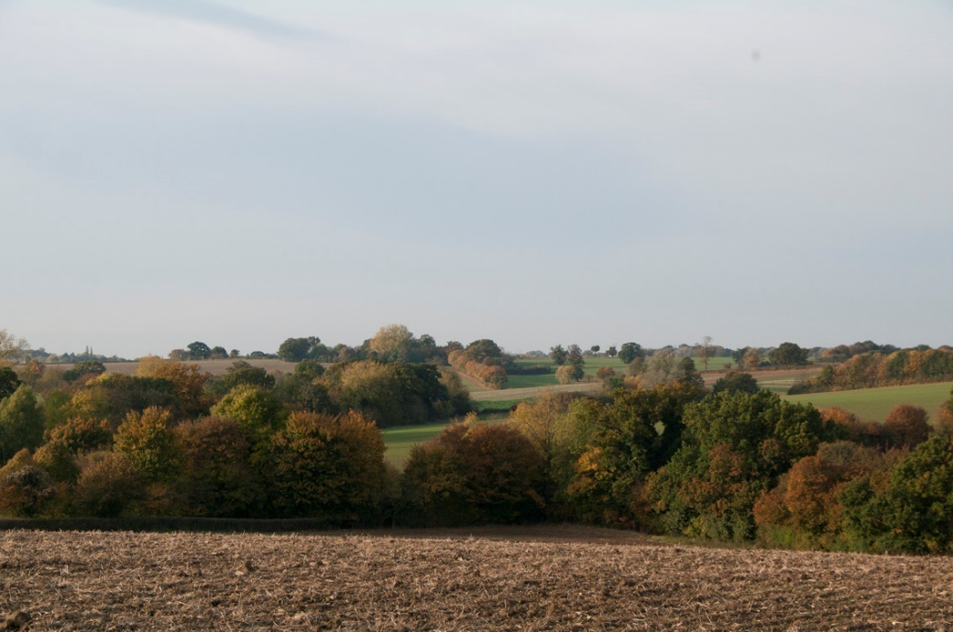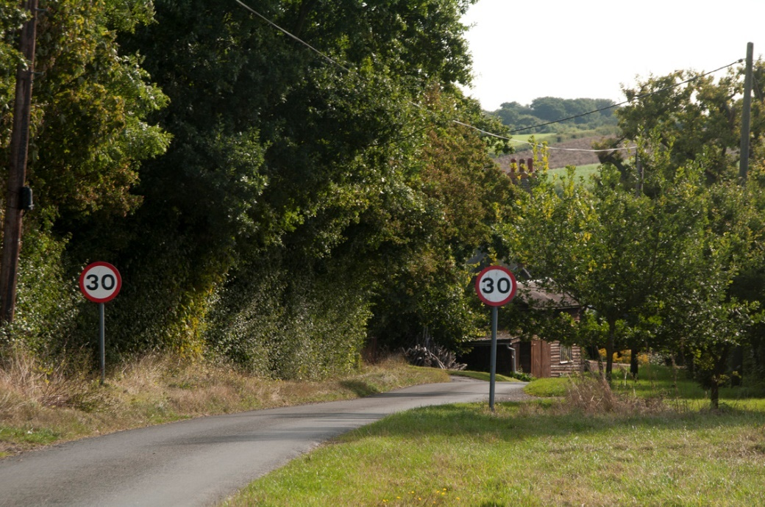
4
2
©EL
©EL
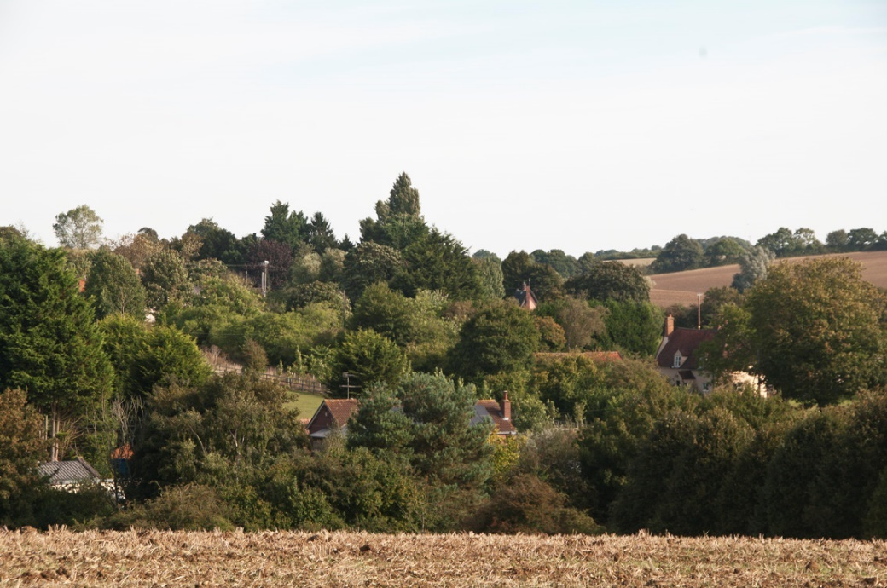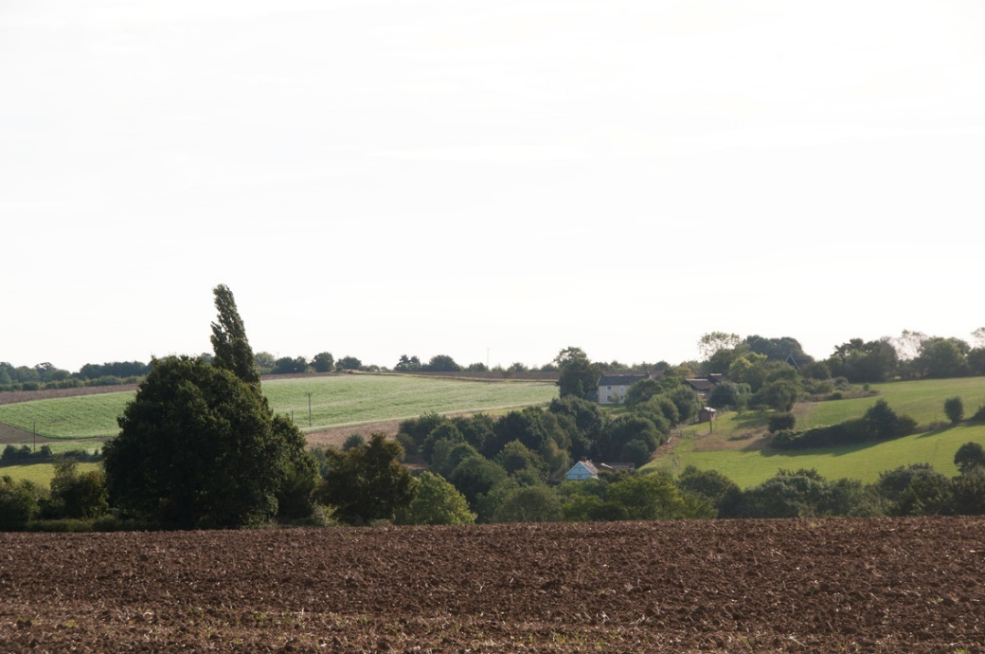
3
1
©EL
©EL
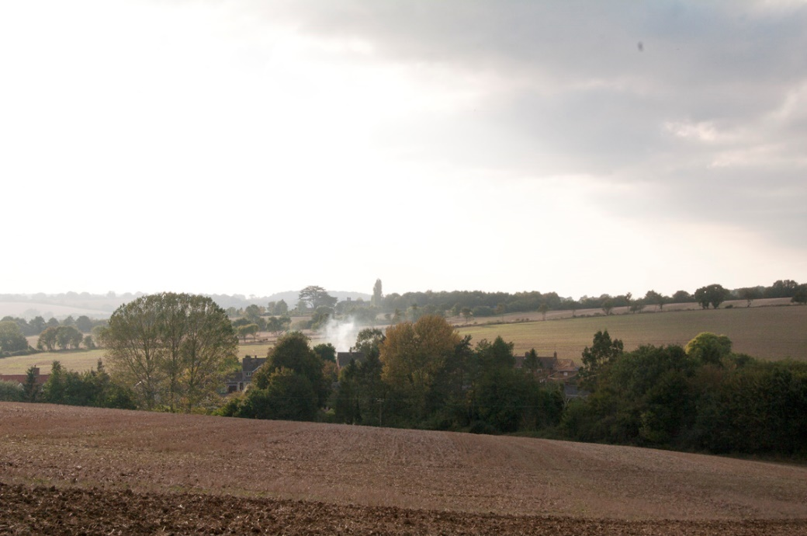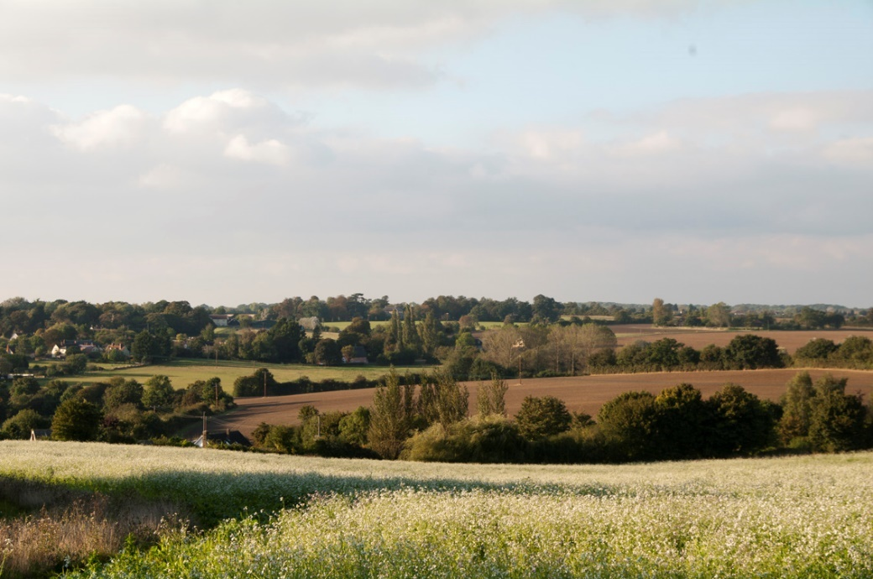
6
8
©EL
©EL
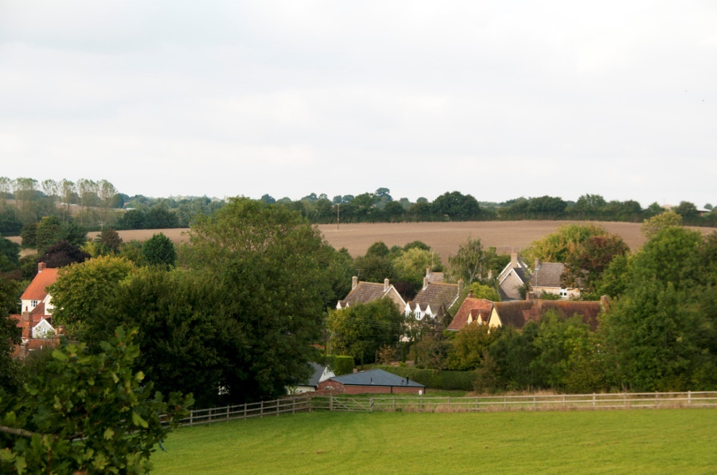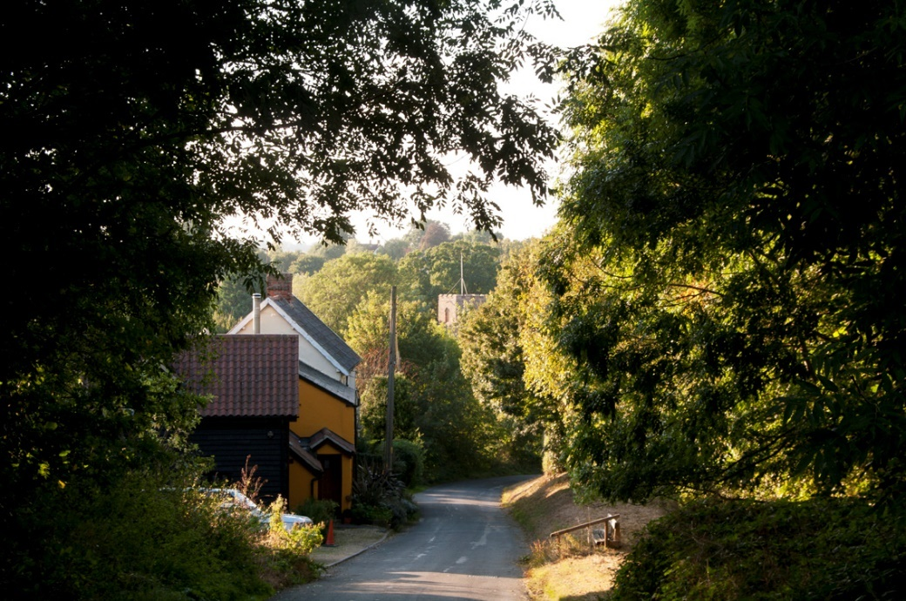
5
7
©EL
©EL
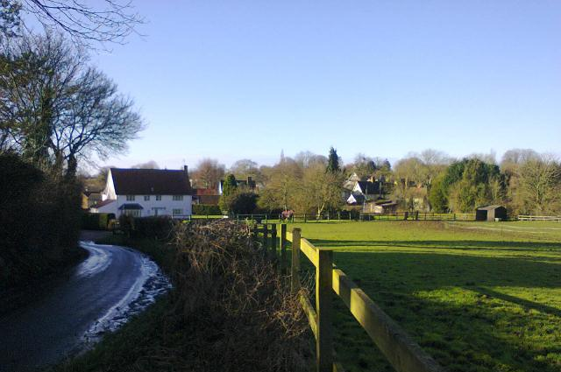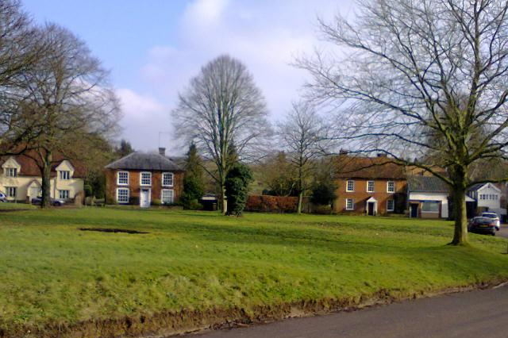
11
10
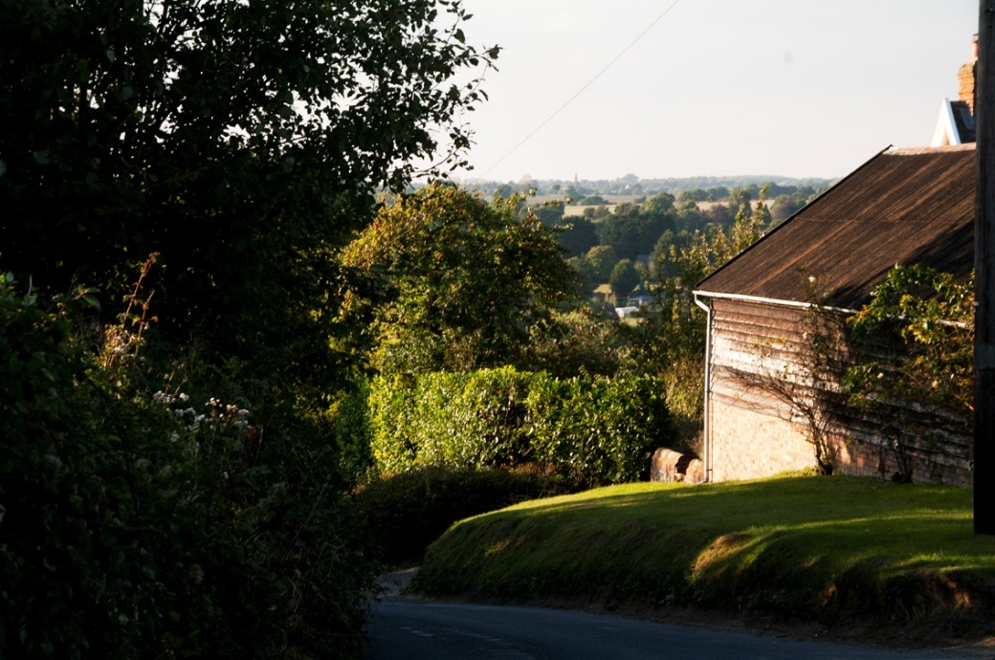
Ref | type of view and location
1 | A medium length view across village showing the integrated relationship of built and natural environment
2 | A long view showing significant tree corridors along the river and a track
3 | A long view over centre of village showing green corridor along road leading into village, itself hidden in the valley
4 | An entry into village and view to hill beyond village
5 | A medium view into the centre of the village with farmland beyond
6 | A long view over village towards Boxted and beyond, with village screened by trees along the river corridor
7 | A short view showing entry into village framing a view of a significant building (the Church)
8 | A long view over village, showing network of hedgerows around the fields
9 | A long view, between farm buildings and trees, across village with a glimpse of the countryside beyond
10 | A short view into village and back of listed buildings on the Green
11 | A short narrow view out of village from the centre to nearby countryside (from the Green)

9
©EL
Settlement Gaps
8.13 The saved policies of the 2006 Babergh Local Plan include Policy CN03 which protects important open space, visually important gaps in the street scene and recreational facilities within villages. Hartest’s distinct character which includes a number of small settlements separated by open countryside has, during community engagement, been identified as a feature that residents especially wish to preserve. The Hartest Character Assessment - Built Environment Report prepared in support of this Neighbourhood Plan notes that there are a number of distinct clusters of houses around the village that are historically significant to the development of the wider village. The gaps between these clusters are important for maintaining this distinction. Accordingly, a number of gaps between settlements have been identified of being of such importance that it is considered they should be preserved from all but essential development that cannot be located elsewhere.

Policy HAR 11 defines the importance of the gaps between groups of buildings and clusters.

Policy HAR 11 - Settlement Gaps

The generally open and undeveloped nature of the gaps separating the distinct settlements in the village, as identified on the policies map and described in the Hartest Character Assessment – Built Environment Report, will be protected from development to help prevent coalescence and retain the separate identity of the settlements.

Development will only be permitted within the identified gap if:
i) it would not undermine the physical and/or visual separation of the settlements;
ii) it would not compromise the integrity of the Local Gap, either individually or cumulatively with other existing or proposed development; and
iii) significant views will be protected.

Fig 8.5

Green Spaces
8.14 There are a number of important open areas within the village that not only make important contributions to the character and setting of the built environment, but also play important roles in providing space for recreation. The Green is a registered Village Green and, as such, is protected from development. The trees are protected by Preservation Orders and the area is actively managed by the Parish Council. Paragraph 76 of the NPPF states that “neighbourhood plans should be able to identify for special protection green areas of particular importance to them. By designating land as Local Green Space local communities will be able to rule out new development other than in very special circumstances.” Paragraph 77 states that the designation should only be used:
- where the green space is in reasonably close proximity to the community it serves;
- where the green area is demonstrably special to a local community and holds a particular local significance, for example because of its beauty, historic significance, recreational value (including as a playing field), tranquillity or richness of its wildlife; and
- where the green area concerned is local in character and is not an extensive tract of land.

8.15 Based on the NPPF criteria, the Crown Garden is designated as a Local Green Space in this Neighbourhood Plan. It is located to the rear of the Crown public house in the centre of the village. It is in the ownership of the public house and currently contains play equipment. The designated site has an area of approximately
0.2 hectares

When considered against the criteria of Paragraph 77 of the NPPF, the following applies to demonstrate conformity:

Proximity | The Green Space is centrally located within the heart of the village and the Primary School, Church and The Institute are all within 300 metres walk
Local Significance | The Green Space provides an important focal point for the community being located adjacent to the public house and also provides an important green wildlife corridor and important views linking the open countryside with Hartest Green to the north.
Local in Character and not extensive | The proposed designation is only 0.2 hectares in area and only relates to the corridor of existing green space that lies to the east of the public house. It does not include the green space immediately to the rear of the Crown, thereby not constraining sympathetic development on the remaining area should it be required in association with the use of the pub.

Fig 8.6 Important Green Spaces

Policy HAR 12 - Local Green Space

The Crown Garden as identified on the Proposals Map is designated as a ‘Local Green Space’ which is protected from new development unless very special circumstances can be demonstrated.

9. Historic Environment and Design

9.1 Objective
Protect and enhance the historic environment

9.2 What the evidence shows
- A large conservation area covers the main built-up area of the village and the countryside surrounding it.
- There are 51 listed buildings in the parish, the majority of which are within the conservation area.
- Many of the listed buildings are of timber framed construction.
- Some local distinctive and historic buildings are not listed but are worthy of protection eg The Institute.
- Development that has taken place of recent decades has not always had regard to the local design and building materials
- Parts of the conservation area, including around the Green, suffer from excessive overhead wiring.
- There was some support from the community for identifying views that are important to the setting of the conservation area that should be protected from inappropriate development.
- Community consultation supported identifying and protecting features, such as walls, hedges and trees that are important to the character and appearance of the village
Conservation area
9.3 A conservation area was designated to cover much of the village, including the landscape setting, in 1973. The extent of the area is illustrated on the map below Fig 9.1 together with the location of listed buildings. Conservation area designation means that the area has special architectural and historic interest and proposals within it to make alterations to buildings, cutting down or lopping trees or demolishing buildings may need permission. It also means that designs for new buildings or alterations to existing buildings should consider the setting and characteristics of the site within the conservation area.
9.4 A Conservation Area Appraisal was prepared by Babergh District Council in 2012 and subsequently adopted as Supplementary Planning Guidance for referral to in determining planning applications within the areas or on sites that might impact on the character of the conservation area. The Appraisal is a short document describing the village and features of the conservation area and lacks the comprehensiveness of appraisals as promoted by Historic England. Their Advice Note number 1 - “Conservation Area Designation, Appraisal and Management” (February 2016) suggests that an appraisal should include, amongst other things:
- townscape analysis: for example, spatial issues such as important views into and out of the conservation area, landmarks, and open or green spaces; or temporal issues, including pre-urban landscape features (such as the lines of former field boundaries) which survive in the current townscape; and
- designated and undesignated heritage assets, including buildings of townscape merit and unlisted buildings or groups of buildings that contribute positively to the character or appearance of the area, scheduled monuments and areas of archaeological interest (this could be combined with the townscape analysis map, depending on the size and complexity of the area).
9.5 Although some character appraisal work has been undertaken to inform the content and policies of this Neighbourhood Plan, it is considered that, given the distinctiveness and importance of Hartest Conservation Area, a more detailed Area Character Appraisal should be undertaken using the Historic England guidance as a framework for its content. This could be undertaken by a working group in the village if it received guidance and support from Babergh District Council to ensure that it is produced in a manner that can be adopted by the District Council as a supplementary planning document.

Community Action 2

The Parish Council will encourage the preparation of a new conservation area appraisal in accordance with the Historic England guidelines and in a form that can be adopted by Babergh District Council as a supplementary planning document.

9.6 The Conservation Area Appraisal noted that “Parts of the conservation area, including around the Green, suffer from excessive overhead wiring.” The Appraisal suggested that, should funds become available, putting the cables underground would improve the situation. This is an expensive exercise but, nevertheless, would make a significant difference to the setting of the numerous listed buildings that surround the Green. Should opportunities arise, an initiative to underground these cables will be pursued.

Community Action 3

Opportunities to underground the unsightly overhead cables, especially around The Green, will be pursued.

Fig 9.1

Listed Buildings
9.7 There are 51 listed buildings of architectural or historic interest in Hartest. Apart from the Grade 1 listed All Saints Church, the remainder are primarily Grade II listed timber-framed houses. Most of these buildings are clustered around the Green, but there are also several listed buildings within the outlying clusters, reinforcing the importance of these clusters in the growth of the village.

Non-listed buildings and features of local importance
9.8 As well as the statutorily protected historic assets there are a number of buildings and features that are of local importance that are not protected. The Institute, overlooking the Green, was built in 1888 as a Reading Room and its design was based on the work of the English Arts and Crafts movement, in the style of William Morris, which is of particular significance locally, regionally and nationally. Local lists of heritage assets play an important role in building and reinforcing a sense of local character and distinctiveness in the historic environment. They enable the significance of any building or site on the list to be better taken into account in planning applications affecting the building or site or its setting. The preparation of a new conservation area appraisal would identify these features and help to reinforce their importance to ensure that development proposals will not harm their character and setting. However, if the new appraisal is not forthcoming in the short-term, it might be appropriate to prepare a local list of heritage assets in conjunction with the District Council and in accordance with the guidelines published by Historic England (Local Heritage Listing: Historic England Advice Note 7 – May 2016).

Policy HAR 13 – Protection of Heritage Assets
To ensure the conservation and enhancement of Hartest’s heritage assets, proposals should:
a. preserve or enhance the significance of the heritage assets of the village, their setting and the wider built environment, including views into, within and out of the conservation area;
b. retain buildings and spaces, the loss of which would cause harm to the character or appearance of the conservation area;
c. contribute to Hartest’s local distinctiveness, built form and scale of its heritage assets, as described in the Hartest Character Appraisal and Hartest Conservation Area Appraisal, through the use of appropriate design and materials;
d. be of an appropriate scale, form, height, massing, alignment and detailed design which respects the area’s character, appearance and its setting;
e. demonstrate a clear understanding of the significance of the asset and of the wider context in which the heritage asset sits, alongside an assessment of the potential impact of the development on the heritage asset and its context; and
f. provide clear justification, through the submission of a heritage statement, for any works that would lead to harm or substantial harm to a heritage asset yet be of wider substantial public benefit, through detailed analysis of the asset and the proposal.
Proposals will not be supported where the harm caused as a result of the impact of a proposed scheme is not justified by the public benefits that would be provided.

Where a proposal affects a heritage asset it should be accompanied by a Heritage Statement identifying, as a minimum, the significance of the asset, the development proposal and an assessment of the impact of the proposal on heritage assets.

Community Action 4

The preparation of a local list of heritage assets that are valued locally as distinctive elements of the Hartest historic environment will be pursued with Babergh District Council.

Design and distinctiveness
9.9 The extensive and distinct historic assets across the village, but particularly within the conservation area, require proposals for new development to have regard to design and use of materials. The conservation area appraisal notes that a range of locally distinct materials are found in the older buildings, including timber-frames, Suffolk red and Suffolk white bricks and some use of flint. Black stained or painted weatherboarding is also to be found on some elevations. It further comments that:
“roofs are variously thatched on the older buildings, or plain tiles where this has been replaced. Slate can be found on the more recent brick buildings and there is also a scattering of clay pantiles, most often on outbuildings, and some of them are the black glazed variety.”

Proposals for new development will need to respect to the distinct built and natural environment features of the village. However, the use of modern materials and design solutions would not necessarily be out of place in such surroundings. Paragraph 131 of the NPPF requires that local planning authorities take account of “the desirability of new development making a positive contribution to local character and distinctiveness.” The Character Assessment for Hartest, prepared as a background document for this Neighbourhood Plan, should be referred to in preparing proposals for new buildings.

9.10 The design of new buildings across the village also needs to take account of modern living requirements which will require managing matters such as the use of energy, minimising the use of water, not increasing the risk of flooding from surface water run-off and managing the parking of cars. In the latter case, Suffolk County Council approved updated parking standards in November 2015 and provides guidance on the design and location of parking in residential development. The Conservation Area Appraisal noted that parking on verges in Hartest is causing damage to the road edge in places and the narrowness of the roads throughout Hartest are not conducive to allowing on-street parking. Proposals for new development must make provision for parking for residents and visitors off the highway in accordance with the current standards.

Policy HAR 14 – Design Principles
Proposals should be informed by the two Hartest character assessment reports (Natural Features and Landscape Features in the Parish and Hartest The Built Environment – Character Analysis) and
a. recognise and reinforce existing local distinctiveness (including special qualities of the landscape, built development and the interrelationship between the two) in relation to location, layout, height of buildings, building materials, density and design;
b. where necessary, be supported by a landscape character appraisal;
c. conserve or enhance Hartest’s heritage assets in line with Policy HAR 14;
d. not involve the loss of gardens and important open, green or landscaped areas which make a significant contribution to the character and appearance of that part of the village;
e. incorporate sustainable design and construction measures and energy efficiency measures;
f. produce designs, in accordance with standards, that maintain or enhance the safety of the highway network ensuring that all vehicle parking is provided within the plot;
g. not expose people or property to the risk of all sources of flooding and incorporate measures to manage and mitigate flood risk;
h. for areas at risk from surface water flooding as identified by the Environment Agency *, be entirely self sufficient in their ability to manage surface water run-off and be designed and constructed to reduce the overall level of flood risk to the use of the site and elsewhere when compared to the current use.
Applicants are strongly, encouraged to incorporate, sustainable urban drainage systems such as green roofs in order to assist with the management of surface water run-off. Surface water disposal to the public sewerage network should only be considered where is has been demonstrated that there are no reasonable alternatives having followed surface water hierarchy.

Details of areas susceptible to flooding can be found on the government website at https://flood-warning-information.service.gov.uk/long-term-flood-risk and is illustrated in paragraph 11.10 below.

10. Local Economy
10.1 Objective:
Increase opportunities for local economic investment and growth

What the evidence shows
10.2 The 2011 Census identifies that 61% of the residents aged 16 to 74 were in employment, a figure similar to though a little lower than that in surrounding villages. In contrast, nearly 22% of the same age group were retired compared with an average of 18% when Hartest and the surrounding villages are compared.

Fig 10.1

10.3 The average distance those living in Hartest travelled to work in 2011 was 27.9 kilometres (17.3 miles). However, 16% of those in employment work mainly at home which is a more than double the rate across Babergh and is also higher than in nearby villages. Not surprisingly, those who do travel out of the village for work travel primarily by car with only a small proportion going by bus or other means.

Encouraging employment opportunities
10.4 Providing appropriate local opportunities for people to live and work in the village is important for the local economy and the potential to support local services. In small villages like Hartest, such opportunities will be limited due to the potential impacts of establishing new business buildings in a village environment or in the countryside. However, opportunities often exist to convert existing buildings, such as barns and redundant agricultural buildings in a sympathetic way that ensures that the building stays in use and that local opportunities for employment are available.

10.5 Tourism could become an increasingly important part of the local economy, especially given the proximity of Bury St Edmunds, Cambridge and the Dedham Vale Area of Outstanding Natural Beauty. There is a lack of tourist accommodation in appropriate circumstances in accordance with the existing policies in the Babergh Local Plan.

10.6 The Babergh Core Strategy and Policy CS17 in particular, supports a range of measures “through the encouragement of:
i) proposals for farm diversification;
ii) the re-use of redundant rural buildings;
iii) sustainable tourism and leisure based businesses (including those offering a diverse range of visitor accommodation, activities or experiences);
iv) businesses involved in the renewable energy / low carbon industry at an appropriate scale for the location;
v) rural ‘business parks’, and workshops, rural and community based business ‘hubs’ that share facilities and other innovative rural enterprises, and innovative business practices such as co-operative or micro-businesses based on shared facilities / services;
vi) and, where appropriate, farm shops and farmers markets”

The Neighbourhood Plan reinforces this support, as long as proposals do not have a detrimental impact on the historic character, landscape setting and road network in the village. The sympathetic conversion of redundant buildings that are built from traditional materials or are of historical or architectural merit to employment uses or to provide tourist accommodation will be supported.

10.7 Proposals for the conversion of barns or other redundant or under-used buildings in the countryside into dwellings will be determined in accordance with Policy CR19 of the Babergh Local Plan Alteration No 2 (2006) and the more recent Policy CS17: The Rural Economy, of the Babergh Core Strategy (2014). The Local Plan states that the conversion of underused buildings in the countryside to residential and tourist / holiday accommodation will be regarded as the least preferred option. The Core Strategy policy supports farm diversification sustainable tourism, including those the provision of visitor accommodation.

Policy HAR 15 – Economic Development

Applications for new economic development uses of redundant traditional farm buildings will be supported, providing it has been demonstrated that they are no longer viable or needed for farming.
Development proposals involving the conversion of farm buildings to residential uses within the defined clusters will be determined in line with HAR3.
Proposals which harm the rural economy will not be supported.

11. Facilities and Services
11.1 Objectives
Support and improve the provision of social, community, recreational and other leisure facilities

Ensure that the level of services and infrastructure reasonably required to meet the day-to-day needs of the village are available

11.2 What the evidence shows
For a village of its size, Hartest is relatively well provided for in terms of service provision. As at September 2016 the following facilities were available:

- Village church
- Pre‐school / Primary school
- Doctors’ surgery
- The Institute
- The Crown pub
- Mobile library
- Motor repair garage
- Butcher
- Regular Farmers Market
- Fish van

11.3 The Hartest and Boxted Institute was designed by architect Sir Reginald Blomfield and built in 1888 as a Reading Room for “the education of the men of the two villages.” The design was based on the work of the English Arts and Crafts movement, in the style of William Morris, which is of particular significance locally, regionally and nationally. The Institute was restored in 2002 with the support of the Heritage Lottery Fund and Babergh District Council and today provides a meeting place for residents and a venue for weddings, parties, performances and meetings.

11.4 The village primary school was established on its current site in 1966 and was expanded in the early 2000s to take two further school years as a result of the county council change from a three tier to two tier structure in the Sudbury area. It has space for 105 pupils but in September 2015 there were only 72 on the school roll and this number is forecast to fall over the next five years. More recently a new Headteacher has arrived and pupil numbers are on the increase. Opportunities to make the school swimming poole and play area available for the community are also being explored. Some additional smaller homes and/or starter homes in the village and school catchment area would potentially help continue the increase in the number of pupils.

11.5 The Doctor’s Surgery is a branch of the Glemsford Practice providing clinic services for short periods on Tuesday to Friday and nurse appointments on Tuesday and Thursday. The Parish Council will support National Health Service England in ensuring suitable and sustainable provision of primary healthcare services for the residents of Hartest.

Policy HAR 16 - Provision and Retention of Services and Facilities

The provision and enhancement of community facilities and services that serve the needs of Hartest will be permitted where they contribute to the quality of community life and improve the sustainability of the village.

Proposals that will result in the loss of existing valued facilities, or premises last used for such purposes, including The Crown PH, Shops, , Institute, Garage, Primary School will only be permitted provided that:
- it can be demonstrated that the current use is neither economically viable nor likely to become viable. Where appropriate, supporting financial evidence should be provided including any efforts to advertise the premises for sale for a minimum of 12 months; and
- it can be demonstrated that there is no local demand for the use and that the building/site is not needed for any alternative social, community or leisure use; or
- alternative facilities and services are available or replacement provision is made, of at least equivalent standard, in a location that is accessible to the community it serves especially by cycling or walking.

Play equipment
11.6 The play equipment in the field behind The Crown provides an important place for the village’s children and parents to meet. However, the site is in private ownership and the village relies on the owners of The Crown to maintain the equipment and to generously allow access to it. Any change of ownership or management could result in the loss of general access to the equipment and leave the children of the village with no formal play area. Notwithstanding this, the green space provides an important open area that significantly contributes to the setting and character of the local area and, under Policy HAR 13, is designated as a Green Space.

Community Action 5

The provision of publicly owned and maintained children’s play equipment in the village will be investigated.

Village shop
11.7 The most significant facility missing from the village is a shop. Residents have long expressed a desire to have a local shop in the village and this has been repeated during the consultation stages of preparing the Neighbourhood Plan. Since the Parish Plan was produced, efforts have been made to establish a community shop but, as yet, no suitable site has been found.

Community Action 6

Investigations will continue to identify a means of financing the running of a community shop to serve the day to day needs of residents and to find a suitable building from which to run it.

The Crown Public House
11.8 The Crown PH is registered as an Asset of Community Value with Babergh District Council. The initiative was introduced by the Localism Act 2011 and provides community groups the ability to nominate non-residential buildings or land within their communities as assets of community value which cannot be sold without the community group being given the opportunity to put together a bid to purchase the asset. The consultation undertaken during the preparation of the Neighbourhood Plan reinforced the importance of the Crown within the community and, reflecting this support, it may be necessary for the business to expand or diversify to remain competitive and viable. Policy CS17 of the Babergh Core Strategy supports the diversification of rural businesses and the provision of tourism accommodation and the expansion of the pub to provide rooms could be acceptable if designed and located sympathetically to its setting in the conservation area, having regard to the Crown being a listed building and provided that any use ancillary to the main use of the Crown.

Policy HAR 17 – Crown Public House

Proposals that make a positive contribution to securing the economic future of the Crown Public House and which provide overnight accommodation will be supported where:

i) such uses are compatible and ancillary to the main use of the public house; and
ii) the design and siting of proposals preserve and enhance the special historic character and appearance of heritage assets, including the conservation area and listed buildings and their settings.

Allotments
11.9 Although the Hartest & District Gardening Club is an active organisation within the village, there are currently no allotments in Hartest. Nationally there has been an increase in demand for allotments and the consultation undertaken in preparing the Neighbourhood Plan identified some support for local provision. The Neighbourhood Plan does not identify a site for allotments but it is considered worthwhile investigating the feasibility of providing some allotments in the village.

Community Action 7

The viability and feasibility of providing allotments in the village will be investigated.

Water supply and flooding
11.10 In relation to water supply and foul sewerage networks, there are no overriding constraints which would prevent the scale of development proposed in the Neighbourhood Plan. There may, however, be localised surface water flooding issues that development proposals should have regard to and where possible, contribute to reducing the problem. The environs of the river, as illustrated in blue on the map below, are classified as Flood Zone 3 by the Environment Agency. It means that there is a 1 in 100 or greater annual probability of the river flooding the identified area.

Fig 11.1 Areas susceptible to flooding from rivers

Fig 11.2 Areas susceptible to flooding from surface water

12. Communications

12.1 Objective
Improve movement to, from and around the village

12.2 What the evidence shows:
- High levels of car ownership;
- Two serious injury road traffic accidents in vicinity of The Green in last six years;
- A further three slight road traffic accidents in the same period;
- The village centre suffers from the volume and speed of vehicles, including HGVs passing through along the B1066;
- Superfast Broadband is available in some parts of the village with evidence suggesting speeds up to 76 megabytes per second are achievable in the centre of Hartest;
- Mobile phones signals are very poor, typically with weak outdoor coverage and limited or no indoor coverage from network providers.

Fig 12.1

12.3 The village is located on the B1066 road that connects Bury St Edmunds with Glemsford and Long Melford. The road passes through the centre of the village forming the western perimeter of the Green and also links the centre to the clusters at Cross Green and Pear Tree Farm. Traffic speeds along the B1066 have been highlighted as a concern, despite the existence of a 30mph speed limit and a flashing speed warning sign is being used in an attempt to reduce traffic speeds. The use of signs and painted lines bring an urban solution to the historic rural environment and are therefore not always appropriate. Large traffic signs in particular can have a detrimental impact on the setting of the conservation area and the removal of white lines has been proven to reduce traffic speeds.

12.4 Given the concerns raised above, it would be fitting to investigate a project to find suitable measures to reduce the impact of traffic in the village in a sympathetic way. One possible example of such an initiative is contained in “Traffic in Villages” produced by the Dorset AONB Partnership in conjunction with Hamilton-Baillie Associates and using the checklist of features contained within the document to inform an action plan.

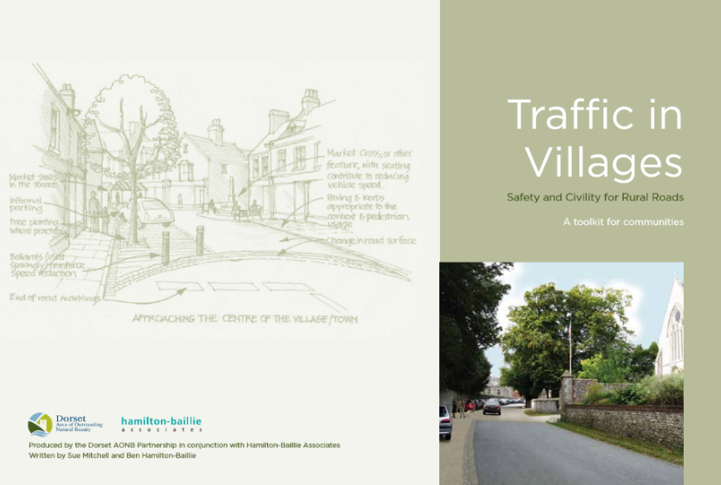

Community Action 8

The County Council will be encouraged to work with the Parish Council to implement environmental sympathetic and self-enforcing traffic calming measures in the village.

Public Rights of Way
12.5 A network of footpaths runs throughout the parish, connecting also to the neighbouring parishes of Somerton, Brockley, Lawshall, Shimpling and Boxted. Footpaths within the parish of Hartest are numbered 1 to 17, though number 4 seems to be in Shimpling rather than Hartest. In addition there are two lanes (Smithbrook Lane and Rogers Lane) and these provide useful links with the footpath network. Darney Lane, towards the northern edge of the parish, is another important and ancient track, leading out of the parish through to Whepstead. In most cases, access to the footpath is from appropriate points along the paved roads - the exception is Parsons Walk, directly from The Green.

12.6 These footpaths are used frequently, some on a daily basis, particularly those close to the village. They are used mainly by residents of the village, enjoying the walking, but also from time to time by visitors to the area, exploring the various footpath routes. The footpaths provide access to the “countryside”, with opportunities for extensive views across the landscape and into the village as well as more detailed observations of plant and animal life in the hedges, across the fields and patches of woodland.

Community Action 9
Support the maintenance and improvement of existing public right of way network including waymarking where necessary

Mobile phones and Broadband
12.7 The availability of mobile phone signals and, more especially high speed broadband, can be a significant determinant in decisions to live and work in a rural community. Mobile phone signals in the village are especially poor, especially in the river valley which can lead to problems when emergency calls need to be made or received. The provision of high speed broadband is equally as important as more and more people shop or work online. There is little actual action that this Neighbourhood Plan can achieve to improve these services but further lobbying for improved services is essential.

Community Action 10
Lobbying for an improvement in the provision of mobile phone signals and faster high-speed broadband will continue.

13. Monitoring

13.1 The Neighbourhood Development Plan reflects the needs and aspirations of the local community at the time of its preparation. However, it is recognised that the current challenges and concerns could well change over the Plan period. As such, Hartest Parish Council, as the “Qualifying Body” for the preparation of the Plan, will be responsible for periodically reviewing and, where required, updating the Plan, to ensure it remains relevant and appropriate to Hartest.

13.2 The Neighbourhood Plan will be reviewed annually as an agenda item at a regular meeting of the Parish Council. The output and conclusions of the review will be documented in the meeting minutes and presented to the community at the Parish Council’s Annual Meeting. Of particular relevance will be the Plan’s conformity with any new or updated local or national planning policies.

13.3 A full review of the Plan will be conducted every five years to confirm its relevance and appropriateness to Hartest Parish. This will be overseen by the Parish Council with anticipated participation from members of the public as appropriate.

13.4 The procedures for conducting the review and proposing any amendments will be in accordance with the appropriate neighbourhood plan regulations in force at the time.

Appendix 1

Babergh Core Strategy Policy CS11 Criteria:
The criteria in Policy CS11 of the Core Strategy requires new development to consider:
- The landscape, environmental and heritage characteristics of the village
- The locational context of the village and the proposed development (particularly the AONBs, conservation areas and heritage assets)
- Site location and sequential approach to site selection
- Locally identified need – housing and employment, and specific local needs such as affordable housing
- Locally identified community needs
- Cumulative impact of development in the area in respect of social, physical and environmental impacts
- A close functional relationship to the existing settlement
- Well designed and appropriate in size/scale, layout and character to its setting and to the village
- Whether it is adjacent to or well related to the existing pattern of development for that settlement
- Meets a proven need such as affordable housing or targeted market housing identified in an adopted community local plan/neighbourhood plan
- Supports local services and/or creates expands local employment opportunities
- Does not compromise the delivery of permitted or identified schemes in adopted community/village local plans within the same functional cluster

Appendix 2

Core Strategy Policy CS15 Criteria
i) respect the landscape, landscape features, streetscape / townscape, heritage assets, important spaces and historic views;

ii) make a positive contribution to the local character, shape and scale of the area;

iii) protect or create jobs and sites to strengthen or diversify the local economy particularly through the potential for new employment in higher skilled occupations to help to reduce the level of out-commuting, and raise workforce skills and incomes;

iv) ensure an appropriate level of services, facilities and infrastructure are available or provided to serve the proposed development;

v) retain, protect or enhance local services and facilities and rural communities;

vi) consider the aspirations and level and range of support required to address deprivation, access to services, and the wider needs of an aging population and also those of smaller rural communities;

vii) protect and enhance biodiversity, prioritise the use of brownfield land for development ensuring any risk of contamination is identified and adequately managed, and make efficient use of greenfield land and scarce resources;

viii) address climate change through design, adaptation, mitigation and by incorporating or producing sources of renewable or low-carbon energy;

ix) make provision for open space, amenity, leisure and play through providing, enhancing and contributing to the green infrastructure of the district;

x) create green spaces and / or extend existing green infrastructure to provide opportunities for exercise and access to shady outdoor space within new developments, and increase the connectivity of habitats and the enhancement of biodiversity, and mitigate some of the impacts of climate change eg. enhancement of natural cooling and reduction in the heat island effect, provision of pollution sequestration for the absorption of greenhouse gases, and through the design and incorporation of flood water storage areas, sustainable drainage systems (SUDs);

xi) minimise the exposure of people and property to the risks of all sources of flooding by taking a sequential risk-based approach to development, and where appropriate, reduce overall flood risk and incorporate measures to manage and mitigate flood risk;

xii) minimise surface water run-off and incorporate sustainable drainage systems (SUDs) where appropriate;

xiii) minimise the demand for potable water in line with, or improving on government targets, and ensure there is no deterioration of the status of the water environment in terms of water quality, water quantity and physical characteristics;

xiv) minimise waste (including waste water) during construction, and promote and provide for the reduction, re-use and recycling of all types of waste from the completed development;

xv) minimise the energy demand of the site through appropriate layout and orientation (passive design) and the use of building methods, materials and construction techniques that optimise energy efficiency and are resilient to climate change (eg. resilience to high winds and driving rain);

xvi) promote healthy living and be accessible to people of all abilities including those with mobility impairments;

xvii) protect air quality and ensure the implementation of the Cross Street (Sudbury) Air Quality Action Plan is not compromised;

xviii) seek to minimise the need to travel by car using the following hierarchy: walking, cycling, public transport, commercial vehicles and cars) thus improving air quality; and

xix) where appropriate to the scale of the proposal, provide a transport assessment /Travel Plan showing how car based travel to and from the site can be minimised, and proposals for the provision of infrastructure and opportunities for electric, plug-in hybrid vehicles, and car sharing schemes.

Appendix 3 SWOT analysis

STRENGTHS | WEAKNESSES
- Attractive location (immediate topography / wider geography) | - Through road traffic (amount / speed)
- Contours, with many fine views | - Lack of "affordable" housing
- A desirable place to live | - High proportion of older residents
- Quality buildings (individual / group) | - Lack of children's play facilities
- The Green | - No general store / post office
- Community activities / organisations | - Lack of other recreational facilities (eg Tennis / 5-a-side football)
- Strong volunteering | - Above average house prices
- Village church | - Heavy vehicles on narrow roads
- Pre-school / Primary school | - Limited regular bus service
- Trees / hedgerows (with high species diversity) | - Poor mobile phone / broadband services
- The Institute and The Crown pub | - Inadequate drainage (surface / foul)
- Motor garage / butcher | - Overhead cables
- Farmers Market
- Village Fete
- Doctors' surgery
- Footpaths network
- Hartest Wood
- The river
- No street lighting
- Parish Council
- OPPORTUNITIES | THREATS
- Scope for additional housing (including "affordable") | - Inappropriate new development
- Creation / support of local employment initiatives | - Development actioned before Neighbourhood Plan approved
- Increased community care | - Damage to views / natural environment
- Community transport provision | - Limited public funding available
- Community shop | - Sustainability of current services
- Amelioration of traffic issues | - Increasing house prices
- Attracting people to Hartest (tourism) | - Unviable Primary school pupil numbers
- Wider church community use | - Closure of doctors' surgery
- Creation of public children's play / general sports facilities | - Closure of The Crown pub as a commercial facility
- The Crown pub as a centre of the community | - Endangered viability of village church
- Community energy generation | - Decline in volunteering
- Creation of Community Land Trust | - Through traffic (amount / speed)
- Exploitation of available public / charitable funding | - Heavy vehicles on narrow roads
 | - Ugly energy generation

Glossary

Affordable housing: Social rented, affordable rented and intermediate housing, provided to eligible households whose needs are not met by the market. Eligibility is determined with regard to local incomes and local house prices.
Archaeological interest: There will be archaeological interest in a heritage asset if it holds, or potentially may hold, evidence of past human activity worthy of expert investigation at some point. Heritage assets with archaeological interest are the primary source of evidence about the substance and evolution of places, and of the people and cultures that made them.
Best and most versatile agricultural land: Land in grades 1, 2 and 3a of the Agricultural Land Classification.
Biodiversity: Describes the range and variety of living organisms within an ecosystem. It can include all living organisms, plants, animals, fungi and bacteria and is often used to indicate the richness or number of species in an area. Such an area can be defined at different levels across the globe or be limited to a local area such as a parish.

Buildings of local interest: Locally important building valued for its contribution to the local scene or for local historical situations but not meriting listed status.
Built-up Area Boundary: These are defined in the Babergh Local Plan 2006 and the policies in the Babergh Core Strategy 2014 also refers to them. They are a planning term that do not necessarily include all buildings within the boundary.
Conservation (for heritage policy): The process of maintaining and managing change to a heritage asset in a way that sustains and, where appropriate, enhances its significance.
Community Infrastructure Levy: A levy allowing local authorities to raise funds from owners or developers of land undertaking new building projects in their area.
Designated heritage asset: A World Heritage Site, Scheduled Monument, Listed Building, Protected Wreck Site, Registered Park and Garden, Registered Battlefield or Conservation Area designated under the relevant legislation.
Development plan: This includes adopted Local Plans and neighbourhood plans as defined in section 38 of the Planning and Compulsory Purchase Act 2004.
Exception sites for affordable housing: Sites for affordable housing development in rural locations where market housing would not normally be acceptable because of planning policy constraints. Homes can be brought forward on these sites only if there is a proven unmet local need for affordable housing and a legal planning agreement is in place to ensure that the homes will always remain affordable, will be for people in housing need and prioritised for those with a strong local connection to the parish.
Green infrastructure: A network of multi-functional green space, urban and rural, which is capable of delivering a wide range of environmental and quality of life benefits for local communities.
Habitat: The natural home of an animal or plant often designated as an area of nature conservation interest.
Heritage asset: A term that includes designated heritage assets (e.g. listed buildings, world heritage sites, conservation areas, scheduled monuments, protected wreck sites, registered parks and gardens and battlefields) and non-designated assets identified by the local planning authority. Non-designated heritage assets include sites of archaeological interest, buildings, structures or features of local heritage interest listed by, or fulfilling criteria for listing by, the local planning authority.
Hinterland Village: Defined in the Babergh Core Strategy 2014 as villages that tend to be small, with very limited facilities and so are dependent on nearby larger villages or urban areas for many of their everyday needs.
Historic environment: All aspects of the environment resulting from the interaction between people and places through time, including all surviving physical remains of past human activity, whether visible, buried or submerged, and landscaped and planted or managed flora.
Infrastructure: The basic physical and organisational structures and facilities (e.g. buildings, roads and power supplies) necessary for development to take place.
International, national and locally designated sites of importance for biodiversity: All international sites (Special Areas of Conservation, Special Protection Areas, and Ramsar sites), national sites (Sites of Special Scientific Interest) and locally designated sites including Local Wildlife Sites.
Local planning authority: The public authority whose duty it is to carry out specific planning functions for a particular area which in this case is Babergh District Council. 1148
Local Plan: The plan for the future development of the local area, drawn up by the local planning authority in consultation with the community.
Neighbourhood plans: A plan prepared by a Parish Council or Neighbourhood Forum for a particular neighbourhood area (made under the Planning and Compulsory Purchase Act 2004).
Open space: All open space of public value, including not just land, but also areas of water (such as rivers, canals, lakes and reservoirs) which offer important opportunities for sport and recreation and can act as a visual amenity.
Renewable and low carbon energy: Includes energy for heating and cooling as well as generating electricity. Renewable energy covers those energy flows that occur naturally and repeatedly in the environment – from the wind, the fall of water, the movement of the oceans, from the sun and also from biomass and deep geothermal heat. Low carbon technologies are those that can help reduce emissions (compared to conventional use of fossil fuels).
Rural exception sites: Small sites used for affordable housing in perpetuity where sites would not normally be used for housing. Rural exception sites seek to address the needs of the local community by accommodating households who are either current residents or have an existing family or employment connection. Small numbers of market homes may be allowed at the local authority’s discretion, for example where essential to enable the delivery of affordable units without grant funding.
Setting of a heritage asset: The surroundings in which a heritage asset is experienced. Its extent is not fixed and may change as the asset and its surroundings evolve. Elements of a setting may make a positive or negative contribution to the significance of an asset, may affect the ability to appreciate that significance or may be neutral.
Significance (for heritage policy): The value of a heritage asset to this and future generations because of its heritage interest. That interest may be archaeological, architectural, artistic or historic. Significance derives not only from a heritage asset’s physical presence, but also from its setting.
Site of Special Scientific Interest: Sites designated by Natural England under the Wildlife and Countryside Act 1981.
Strategic Environmental Assessment: A procedure (set out in the Environmental Assessment of Plans and Programmes Regulations 2004) which requires the formal environmental assessment of certain plans and programmes which are likely to have significant effects on the environment.
Use Classes: The Town and Country Planning (Use Classes) Order 1987 (as amended) puts uses of land and buildings into various categories known as ‘Use Classes’.
Wildlife corridor: A wildlife corridor is a link of wildlife habitat, generally native vegetation, which joints two or more larger areas of similar wildlife habitat, Corridors are critical for the maintenance of ecological processes including allowing for the movement of animals and the continuation of viable populations of plants and animals.

Technical housing standards – nationally described space standard” (DCLG 2015)
http://www.lifetimehomes.org.uk/pages/lifetime-homes.html

